Names

- Aamped Electronics

- Paper Circuits

- Postcard Circuits

- Circuit Cards

Cards

- resistors, look and feel

- voltage divider

- thevinin equivalent circuit

- Ohm's law

Sibling Cards

- battery cards
  - power supply cards
  - voltage regulator cards

- capacitor cards

- inductor cards

- IC cards

- Measurement cards
- Display cards
- Network cards

- USB cards

Featuring

- voltage measurement

- current measurement

- resistance measurement

- impedance measurement

- waveform measurement

With

- Input Indicators

- Output Indicators

- Standalone Operation

And

- Explanation of Function

- Expected Values

- Liberatable Parts

- On Off Switch

- Requires

- Battery Card

- Simulation Software Files

- Guaranteed Buyback/Recyclability
- Drop in any mailbox to recycle

- Analagous to software functional blocks
It should be possible to turn a chalkboard drawing into an equivalent paper circuit implementation.
- Intersperse digital technologies where necessary

Technologies

- Laser cut conductive and insulating layers

- Recycle spent materials

- Photographic covers

- Stiffened cardboard backs

- Water resitant coatings

Applications

- Education

- Rapid Prototyping

- Bioinformatics – Enzyme Simulations on a Card

Feeder Sources

- Electrical Engineering Cookbooks

- Hallstad Java

- TINA Spice Existing Examples

10/5/2009 – PostCards Rule
Rules of PostCards

1) They should demonstrate an important and basic principle as a stand-alone.

2) They should have some kind of simple user control(s) to vary parameters.

3) They should be able to participate as members of a larger mural circuit.

Zafar –

Good to hear from you. Chapter 1 is attached, you will find it to be review.

You must already know that I want to make science and electronics knowledge available to young, old, rich, poor, advantaged and disadvantaged.

And I want this knowledge to bring peace and effective communication to everyone. And I want those who reject God and His love to be left out of the mix.

One thing I have always been skilled at, from my time at JPL to now is recognizing small changes that can accelerate progress.

I want to make circuit construction look and feel like block diagrams.

Block diagrams are quick to construct, easy to change and inexpensive to prototype.

The desktop metaphor from Xerox and Apple gave us the PC revolution.

I believe a similar revolution is brewing in electronics, and with your help, it will happen.

Imagine that instead of spinning evaluation boards, that we print them ON PAPER with conductive ink.

Each evaluation board becomes a paper postcard that can be mailed, tested, and traded… like a baseball card.

The Three Bears Metaphor:

Sampled parts don’t have the traction of evaluation boards. High integration complexity. Too many pins. The porridge is too hot.

Evaluation boards are too expensive for the Mongol hoards of prototypers who want in the surface mount game. The porridge is too cold.

PostCardKit™ circuits lower the integration complexity, while keeping the cost down. The porridge is just right.

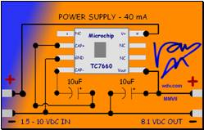

For the postcard radio I have three candidates:

1) crystal radio card – as described in the chapter I sent, using a switched capacitor instead of inductive tuning.
2) tayhoe detector narrow band kit, like the softrock receiver.
3) TI-SDR “teaser” card:
a) receiver ONLY
b) direct conversion, no IF
c) 1-1000 MHz continuous bandwidth or best upper bound.
d) DSP also used for frequency synthesis and decimation instead of FPGA
e) user’s PC and software is used for control surface and demodulation
f) postcard connects to PC via USB 2.0 High Speed 45 Mbps - instead of RJ-45 ethernet

All the best,



L. Van Warren MS CS, AE
web wdv.com
land 501.664.0411
cell 501.231.5426
skype lvwarren
LinkedIn vanwarren
FCC AE License AE5CC

"Slow is Fast and Fast is Slow"

-----Original Message-----
From: zafar taha [mailto:zafartaha@gmail.com]
Sent: Monday, November 19, 2007 4:24 PM
To: van@wdv.com
Subject: Zafar Taha

November 20, 2007
Van Warren, M.S., Director
hiTek Conceptual Design
Little Rock, AR - USA.
Ref: Intent to collaborate on current or future projects
Dear Van,
I have always been impressed by the way you have estabilished your own consultant company and are working on very interesting projects. My discussions with you have always inspired me to be a better person/engineer/scientist. It is a very pleasant coincident that we both have some common areas of research and learning in science and technology. I wish to propose to collaborate on some of projects. I am open to work on any of your current projects or develop a new project together to work on it.
Since I have become Assistant Professor, I want to pursue research and learning in areas other than my primary research area.
My methodology for collaboration is based on discussion of problems available, exchange of ideas leading to possible solutions,
modeling the proposed solutions, analyzing the proposed solutions through simulations leading to conclusions. Develop proposal to
obtain funding and so on.
Even though I live in a different country now, I can be easily contacted on my VOIP phone number (501-542-4183). I have a decent internet connection for voice or video conferencing. I believe that if one works hard on something then God will open the doors of knowledge for him.
Eager to hear from you.
Sincerely
Zafar Taha
A friend
P.S:
1. I am waiting to read your chapter on cognitive radio.

Dear Kyla and Gary –

Words cannot express my appreciation for your diligent help in solving the riddle of the paper radio and paper circuit problem. Unlike past efforts, it appears we are closer to the cutting edge this time, with January being the key filing date.

Since the dot com crash, things have been quite hard for inventive types, and the market seems to be reorganizing itself around different priorities and perceptions of values. I spend a great deal of time tracking those trends and assessing market entry points.

As I went through the ordered stack you sent while eating my lunch, it was like I was tied to my chair, receiving slap after slap of bad news. Of course I take these things in stride. I’ve been tied up by some the best. Besides, patents are truly interesting.

Then as I pondered what it all meant, I saw one GAPING hole in the prior-art picture.
No one has patented an IC postcard.
No one has patented a paper IC demo circuit card, which applies to ALL integrated circuits, not just the small niche of radio.

Everyday companies like TI, Analog Devices, Maxim-IC, Linear, National, and many others send out expensive printed circuit boards whose sole purpose is to demonstrate the function of one chip. These boards are bulky, cost up to $30 each to mail and are then quickly forgotten. No one has commodized the IC PostCardKit™ and that is a HUGE market. Coincidentally I have already built, tested and used a working prototype. Maybe now I just need to send it in the mail!

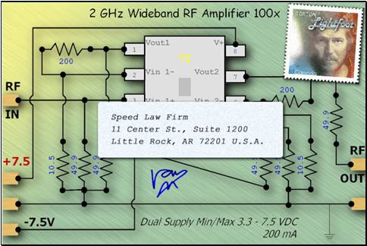

Due to capitalization issues, I will not pursue this further right now, but I was happy to see that all was not lost. You have been so helpful and I cannot thank you enough for that. As always I remain

Yours truly,

L. Van Warren MS CS, AE
web wdv.com
land 501.664.0411
cell 501.231.5426
skype lvwarren
LinkedIn vanwarren
FCC AE License AE5CC

"Slow is Fast and Fast is Slow"

In preparing for my book on SDR, I have reviewed what the industry as a whole is doing, and the bird’s eye view has given me some insight;

My principle observations are these.

Many historical innovations in radio have come from hams who homebrew equipment. For them there are significant

- Barriers To Entry

- Pin Count:
High Component Pin Count can be intimidating to many potential adopters of SDR. I2C is helping this somewhat.
High Internal connectivity is fine, but the outside world needs as few pins as possible to speed design, fab, and utilization.
- Surface Mount / Ball Grid Arrays
- Evaluation Board Cost
- Narrow Band Focus
- USB Interface Complexity
- FPGA Complexity and Huge Development Times
- High Software Costs: Mathlab, Labview, Simulink are very costly.
- System Complexity
It takes many years of training and experience to become good at RF design, or good at S/W design. SDR needs both!
- Interconnection sensitivity and cost: SMA connectors can cost $30 each!
- Loading registers on programmable chips like PLL’s requires a microcontroller.
- Reconfiguring filters requires an digital pot or varactor. This should be a chip.

Many people working with SDR are software engineers, who are “all thumbs” when it comes surface mount technologies and spyglasses.

For them, evaluation boards are key enabling bits of technology. But many evaluation boards are expensive.

How do we get the cost down?

Answer, eval “postcards” contain chips mounted on paper, using conductive ink.
I have prototyped this technology for the TI THS3202 and it looks promising.
I would like to license this technology to TI with the objective of getting the unit cost as low as possible for innovators everywhere.

2) software radio’s aren’t just software.

There remains, for the foreseeable future, RF sections soft radios.

These consist of antennas, antenna matching systems, wide band amplifiers, mixers, oscillators, DDS, synthesizers, PLLs, VCO, VXCOs, VFO’s etc.

That market is as follows, ATMEL, TI, Mini-Circuits, National, Maxim, Linear, Fairchild, Freescale and NXP.

That is just to pull the RF out of the sky.

Then we need to digitize the RF, and for that we need very high speed, high resolution ADC’s. That market looks like this.

After we digitize the RF, our options bifurcate.

We can either go to desktop system or DSP.

Desktop examples include gnuradio’s USRP, or hpsdr’s Janus/Ozy, or Flex Radio’s SDR1000, or RF Spacee SDR I/Q or the amazing SoftRock ($30 complete!)

DSP examples include TI’s softradio evaluation module. These are being snatched up by telecomm’s and cellphone designers, but that isn’t the full width of the market.

Although CPU and DSP rates are increasing, the comm frequencies

Rocky Racoon

Wideband Radio

Binaural Radio

Helpful trends

There are some trends that are mitigating these barriers identified above, but they they need to be pushed much harder to produce breakthrough technology.

One trend is TI-Tina, allowing circuit simulation.
Another is National’s Webbench, which allows RF design without downloading any software.
TI-Filter Pro is very useful, but lacks large enough displays to resolve high frequency designs and key circuit details.
Analog Devices offers

Filter Pro, dated at 2001, is hopelessly out of date, for what a key piece of software it is.

Ideally it would be linked in a web-based design chain to a simulation tool, similar to National’s webbench so that a suggested design could be simulated, and then built online with BOM.

No one has yet linked BOM to a direct order via a distributor but whoever does that will be rocking and rolling in dough.

The next step after that is to send the prototype out for paper boards and trial fab.

So you sit down, design you system, click a button and get a working system in the mail. That is the final frontier.

All the best,




L. Van Warren MS CS, AE
web wdv.com
land 501.664.0411
cell 501.231.5426
skype lvwarren
FCC AE License AE5CC

Slow is Fast and Fast is Slow

Didn't you see the flashing electronic cards? Yikes, they're hot on the trail of my paper circuits, or so it would seem.

Worked all evening the power supply. Hardest part was the spring loaded contacts. I'm using foam. It might work.

I’m trying to get these paper circuits to the point I can build them in paper, then in glass. My idea is that, “drawing the circuit IS the circuit”, like the Egyptians who believed that their writing was “alive”.

I want them to fit on a 3 x 5 format for right now. Eventually they will slide down vertically into a rack, Star Trek, HAL 9000 or something.

Trying different things. Perhaps you will get an idea from this. This is the age of collaboration and all.

My feeling is that these chips come from silicon and silicon is from sand and sand is from the earth. So there is connection there. I want to combine the elemental feeling with the functional purpose without the two clashing. This is hard and I do not feel I have in the least bit begun to accomplish it.

I want to make something than artist, an archaeologist, or even a child might make some sense of and yet something an expert would find interesting.

I also want to have one unique pattern per part. Like color coding but less boring. Pattern coding, rather than color coding.

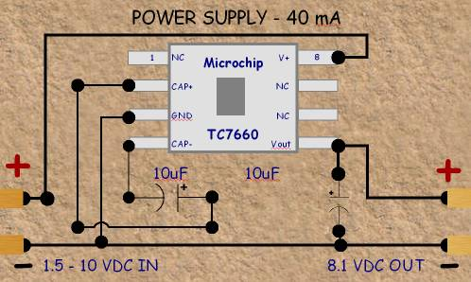
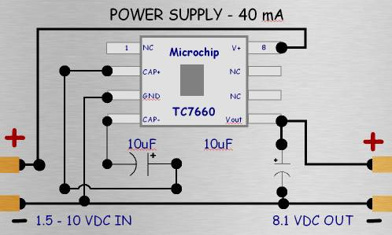
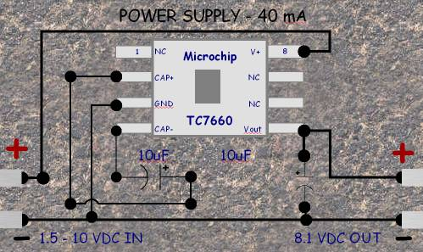
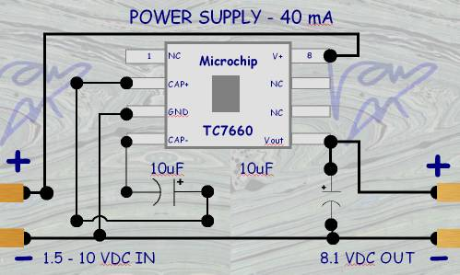
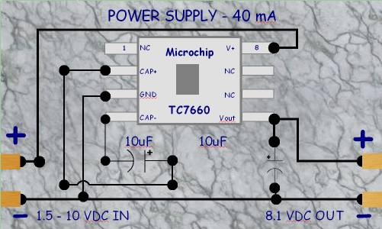
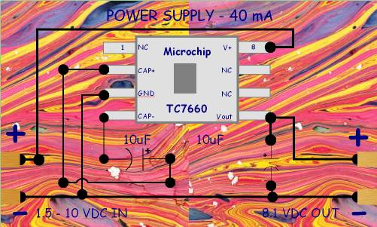
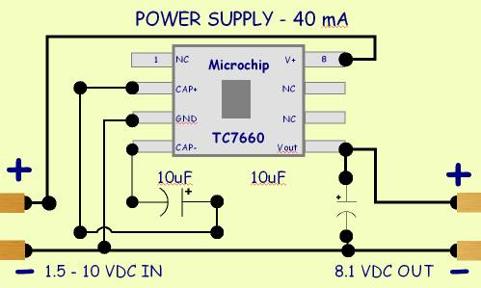

All the best,
-Van

L. Van Warren
Warren Design Vision
wdv.com
501.664.0411 land
501.231.5426 cell
501.588.1370 skype

******************************************************************
* *
* CyberCircuit Demo - To_Order.txt *
* 9:25 PM 9/22/96 *
* This file contains last minute information and updates. *
* *
******************************************************************

This program is a demo version of CyberCircuit and CyberCircuit Plus.
In this demo version you will find 100 items to view and print.
If you don't find a particular circuit on the demo, look at cclist.txt
or ccplist.txt to find a listing of the circuits and information that are
on CyberCircuit and CyberCircuit Plus.
CyberCircuit contains 680 circuits, formulas, charts, etc.
CyberCircuit Plus contains over 1100.

paper on design methodology

factoring

block design

dataflow debugging

time to create vs
time to debug

rapid prototyping vs
rapid troubleshooting

muralizing

the cost of self-diagnostics

the right amount of self-diagnositcs

the cost of test jigs

statistical quality control
checking parameter boundaries rather than parameter spaces
places where this doesn't work

apparent complexity
plain English

time constants

sockets

reuseability

calculus related rate problems

point by point debugging

--------
most popular IC's

1) 7805 5V voltage regulator 7812, 7815
2) 741 operational amplifier
3) 555 timer
4) 7400 TTL

--------
the point of entry

electronics education for kids

audio amplifiers: http://is.gd/4jp7p

analog effects

digital effects

popular circuits

----------

a design grid

power and low frequency signals routed below the plane in the base plug-in grid

RF and high frequency signals routed above the plane.

rectangular topology

---------

LM386 audio amplifier

-------

filters: Maxim tutorial: http://is.gd/4jpv5

------

what if a dataflow diagram could be implemented (transparently) as a digital or analog component.

how could you support this in a simple way? with wires, boxes, inputs and outputs.

----

what about using FPGA's as function blocks.

interconnecting FPGA's is a purely functional process

hacking their internals is an imperative process, doing whatever is necessary.

For example: implement QSort as a sequence of function blocks.

-----------

implement a simple function block editor where the blocks can be analog or digital

-------------

analog, digital, is there a third, orthogonal rep? as in, neural, using the branch tube branch construct?

