TINA-SPICE simulation of the regenerative receivers with the MPSA18 small signal NPN transistor and with the NXP NPN 9 GHz wideband transistor

Simulate the MPSA18 circuit and see if the NXP transistor will work.

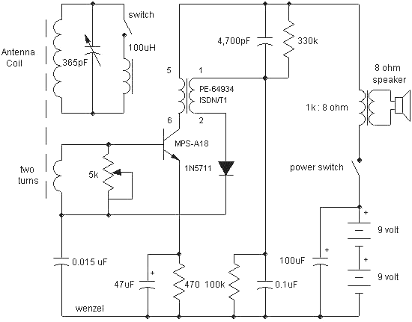

Simulate this regen receiver, the NXP can't handle 18 volts though.

