Saturday, December 03, 2011

Maxim VCO notes

http://datasheets.maxim-ic.com/en/ds/MAX2605-MAX2609.pdf

1) about 70 nH inductor required for 217 mHz
2) VCO's are tuned using the output of a PLL loop filter for exact voltage control from 0.4 V to 2.4 V.
3) These VCO's have a spur signature that can be low pass filtered for image reduction.

Bypass Capacitor Notes

http://www.seattlerobotics.org/encoder/jun97/basics.html
http://www.intersil.com/data/an/an1325.pdf
http://www.ti.com/lit/an/scba007a/scba007a.pdf

- use 1 or 2 for medium and high frequency noises
- locate as close as possible to Vcc pin on I/C
- use one per I/C
- use multi-layer ceramic chip capacitors for most apps OSCON or X2Y for demanding apps
- 0612 package is preferred to 1206 since ESL is 95% lower
- use smaller package for smaller capacitors, otherwise they don't do anything
- use via's to route capacitor connections to ground plane OR use a wide ground trace to keep impedance low
- place the smaller capacitor closer to the device
- use 1uF for power supply droops and .01 uF for digital switching transients

Thursday, December 01, 2011

Articulated the underlying goal.

Given an RF signal determine its originating location, its frequency, its modulation and its demodulation.

Build the 6 Meter Super Regen with the following mods:

1) Use the AD5530 gain block in front of the regeneration section to decouple the antenna.
2) Change antenna impedance to 50 ohms.
3) Create a band-switching array using different coils and capacitors.
4) Use an audio pre-amplifier for the output section to decouple the radio.
5) Use an audio amplifier after the pre-amp.
6) Add a frequency counter.
7) Add an oscilloscope display to observer the waveforms before and after processing.

Lets say we add the AD5530 gain block to the front-end of the radio.

To have the AD5530 eval PCB board printed, assembled and tested made for the sample chip would cost:

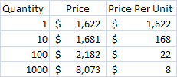

THUS WHEN PROTOTYPING USE THE VENDOR EVALUATION BOARD TO MINIMIZE COST!!
Unless you can get paper circuits working.

Even so, considering assembly costs, since most of what you do is prototyping, the eval board is the best option, period. Don't even waste time doing anything else unless you have a full blown product.

Wednesday, November 30, 2011

you want to use a colpitts regenerative receiver

you want to use a jfet, it does not have to be high gain, but it does have to be high frequency and low nose

you want to use a coil (array) wound on a toroid so it can be small.

you want to use a standard tuning capacitor and a bandspread capacitor

the tuning range is the square root of the capacitance variation, so varactors are not acceptable, unless they are in parallel.

you want to use an untuned, wideband gain block to decouple the RF stage.

you MAY want an isolation capacitor and an attentuating resistor on the antenna

http://www.ke3ij.com/AGC-80.htm is a bipolar regen, i want a JFET

you want to feedback the signal in phase, so you may just want a phase control section.

You might want to do this with blocks instead of discrete devices.

Here is an example:

VHF Regenerative Receiver

Submited By Nadisha 4S7NR
Looks very simple. But need bit experiance to build this receiver. It can be tuned from 140 to 150 Mhz covering the whole 2m band. This has a Super Regenerative detector. When properly tuned and aligned the receiver is very sensitive. The original author R.H.Longden writing in a Practical Wireless artical says that he could hear transmissions of 10 miles with a 6 inch wire antenna.
Receiver must be enclosed in an metel box and Tuning spindle should be fixed with a plastic knob. One should never try to construct this on IC boards or Vero boards.
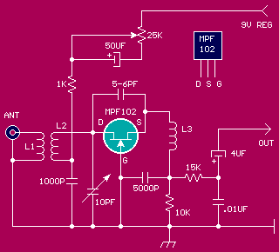
L1 and L2 Coils should be wound using 18 SWG wire and L1 is only one turn where L2 has 4 turns (7/8 inch long). They are air wound on 1/2 inch diameter form. L2 should be next in-line to L1. Changing the turn spacing of L2 change the frequency. So you will have to experiment and find where it tunes. If you have an signal genarator - with in no time you will be in the business. L3 is not very critical, it has 30 turns of 26 SWG wire on a 1/4 inch diameter air core.
Once evry thing is okay, connect an audio amplifier, similer to LM386 and a sutable antenna to the receiver. Turn the 25k pot (Regen Control) where a strong hiss begins. This is roughly the correct posision. This hiss should cease when any signal of sufficiant strength is tuned in. Tune the 10pf tuning cap to search any stations or tune your signal genarator to see where the receiver is tuned. Once you know the place, adjust the coil. To increase the frequency, you will have to stretch the turns of L2.
http://www.qsl.net/qrp/rx/vhf-rx.htm

------------- Colpitts Detail From google books

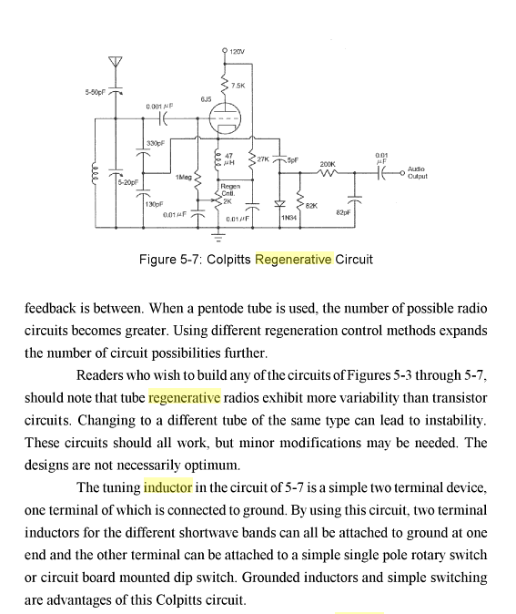
Wednesday, November 23, 2011

Types of Signals for Regen vs. Super-Regen Detectors:

Super-Regenerative Detectors work well for wide-band signals such as FM, where it performs "slope detection".

Regenerative Detectors work well for narrow-band signals, especially for CW and SSB which need a heterodyne oscillator or BFO.

A super-regenerative detector does not have a usable heterodyne oscillator - even though the super-regen always self-oscillates,
so CW (Morse Code)and SSB (Single side band) signals can't be received properly.

-- from wiki

