Radio Frequency Source Location
Using
Software Defined Radio

L. Van Warren / AE5CC / wdv.com
12/26/08

Blah blah blah intro

State it.
State it and illustrate it.
Review it.

Key Process

- Extract and compress features from a narrow frequency band. - -- - --, - -- - --
- Time stamp features to create Time-Stamped Features (TSF’s) aTSF1, aTSF2, … aTSFN
- Compare streams of TSF’s from pairs of receivers.
- When matching TSF’s are found, compute time offset, hyperbola and package Matched TSF’s (MTSF’s)
- Compare streams of MTSF’s.
- Compute hyperbolas, curves, intersections and locations.
- Display locations.

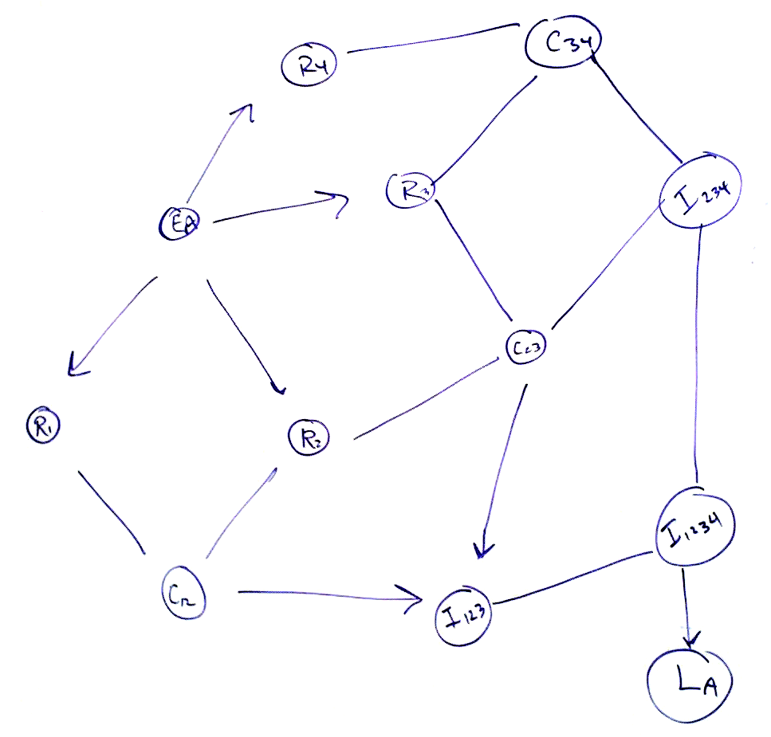

Discuss each step in process.

Analyze the processing required for each step.

Determine the packet size for each step and estimate the bandwidth.

Determine the equipment architecture to fulfill requirements at nodes.
What must be collocated, what may be distributed.

Enable the architecture to be self-similar for redundant readings. That is n = 4 is the theoretical minimum for locating a signal, but n >> 4 is desirable for computing actual locations due to multipath, noise and other concerns.

When a signal is very important, as in an emergency, more receivers and other system components on the grid can be dedicated to locating that specific signal.

Investigate the ping-back SDR work, which allowed people to “see themselves” and see if it looks like radiolocation work you are doing.

When multiple solutions appear, use those to measure ionospheric effects and multipath.

Plot the results in 3D using the NASA ionospheric Google™ Earth map as a base to show interactions as they actually are.

Use ham radio transmissions to create a 3D frequency dependent map of the ionosphere, which is, like the sky in its enchanting qualities. Be an Indian.

Discussion of Process Steps

- Extract and compress features from a narrow frequency band

AM signals appear in tracks. These tracks can be as narrow as 50 Hz for telegraphy, to moderate width of 3000 Hz for voice, to 17000 Hz for broadcast FM.

A common feature of all signals is that they rise temporarily from the noise floor. Repeated excursions from the noise floor occur in unique patterns. The longer the pattern is sensed, the more unique the pattern is.

An initial goal of accomplishing step 1 is to allow a user to adjust the noise floor and clipping limits interactively. Once the processing is understood, it can be automated. This will enable unique and useable patterns to emerge. These one-dimensional features can be encoded as a number with digits of significance. This is an analog to digital conversion process and carries with it all the apparatus of same.

Numbers from multiple receivers can be time stamped and compared for similarity. The tolerance on the similarity can also be an interactive feature, tuned by the user until it is understood and automated.

In order to prototype, this first step it will be necessary to control at least two soft radios simultaneously.

At least one of the soft radios will have to be remote, at a sufficient distance from the first to have a delay time that is significant compared to other system errors, without being so far that the signal pattern is markedly changed or frequency-shifted.

The time scale over which the unique pattern is detected and experienced by a human user is much longer than the time scale over which the delay in receiver arrival takes place. A user might have to observe (and compare) 5 or 10 seconds of communication to determine possible similarity. A delay of a microsecond is 1000 feet of positional difference, or uncertainty. A pattern length of 10 seconds is 10 billion feet, around 200,000 miles, or about 8 orbits of the earth. An ADC sampling at 400 MSPS will generate 4 billion samples at 12 bits per sample will generate 8 gigabytes of data for a 10 second monitoring period. Far less data is necessary for creating a unique pattern, how much less is not yet known until we build a system for processing it in real time. For a Morse code signal, how many operators on a given frequency would be transmitting the identical code at the identical speed? Far fewer.

Consider a telegraph signal appearing at 120 words per minute. This is roughly 1000 characters per minute or about 20 characters per second. 10 seconds of monitoring would produce 200 characters of unique communication on that narrow frequency band.

Therefore, we have some mapping that takes 8 gigabytes and produces a 200-character pattern.

This means a sampling ratio of 8 billion samples in to 200 samples out, or 40 million to 1 sampling ratio.

The critical measurement, which can be marked anywhere in the transmission is the time of arrival difference in that 200 character pattern.

A similar argument can be made for a voice signal. We don’t actually have to monitor the full bandwidth of the voice signal; we just have to focusing on the same narrow band of it on the same frequency between the two (or more) receivers. Once two candidate signals are observed to be similar we mark them.

Typical offsets for terrestrial signals would be less than 24,000/186,000, about a tenth of a second.

To determine position to within 1000 feet of uncertainty the timing would have to be accurate to a microsecond.

If we are willing to tolerate this positional uncertainty, we can digitize the RF at a lower rate, say at a MegaHertz or so. This can be done by digitizing an intermediate frequency obtained by heterodyning or mixing (multiplying!) the original narrow-band signal with a local oscillator and filtering the RF to obtain the IF and then digitizing that. This reduces the load on the ADC, and the data load on the machine.

However, the lower the IF, the more loss of positional accuracy we have. So it is desirable to keep the IF choice flexible, but accurately calibrated.

Now we have 2 million samples in to 200 samples out, or 10,000 to 1 sampling ratio.

Now we only have to process about two Megabytes per second of data, well within the reach of modern CPUs. We can always refine performance as hardware and software improves.

(Do test measurements in ‘C’ here to determine what this number actually is!)

You can use this system to build a radar, especially since the IF allows you to bring the sampling rate down to a manageable level.

If you originate the source signal by bouncing it off of a target, the target can look like an emitter and you can measure it using the hyperbolic methods to be discussed below.

