Battery Holder Notes:

- The battery is attached via a 5 mm square pad through which spring-loaded pins project.

- The spring loaded pins dimensions are:
  - 4 mm (0.156”) cylindrical base
  - project through a 1.626 mm (0.064”) diameter hole.

- The laminate of FR-4 MiniBoardPro is 1.62 mm (0.064”) thick after plating.
- The battery pin shaft is 1.68 mm (0.066”) and thus extends .04 mm above plane when inserted in the back.
- The battery pin itself extends 1 mm (0.039”) above the plane.
- The battery contacts are recessed by 0.52 mm (0.020”) above the plane.
- The battery labels are recessed into the battery.
- The pins will thus be at 0.48 mm (.0195”) exactly mid-stroke with the battery in place.
- It is essential that the battery be held flush against the PCB by the rails.

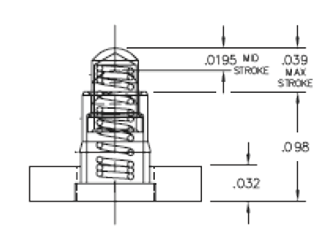

10) The rails shall be a carbon fiber rail fastened with a thin film of epoxy resin.

11) PCB is 38 mm (1.5”) x 64 mm (2.52”) x 1.62 mm (0.064”) without parts.

