I needed a bike flasher and bike light so I am considering building one.

This note serves to document my analysis, design, and build processes.

Functional Considerations – The “What” Phase

1) There is an argument that says you need:
a fixed light:
as a bike headlight to view the road surface
as a predictable position reference for other riders
a flashing light:
to alert other cars to your presence as a bicycle
a moving light:
that identifies me as anomalous to the driver and therefore
to be paid attention to.

the term fixed is ambiguous. Is the light a) not flashing, or b) mounted to a fixed reference frame?

2) How often are you driving or riding, you see a light but you can't tell if:

it’s a bike
or a car
or a motorcycle
or a streetlight
or something else
or if it’s really moving at all!

3) I like a light on my helmet because:

wherever I look, there is a light on the subject

if i look at a car, they see that the light is attached to me the cyclist
(possibly by the kinetic depth effect)

4) I want a light on my helmet to be LED driven because

LED's use less power per unit of light emitted

can be as bright as I want

can be flashed or steady state.

5) I want control over the flashing frequency and duty cycle because

I can dim the light using a low duty cycle

I can minimize power consumption using a low duty cycle

I can change the rate of flashing:

To exceed the flicker fusion rate
To avoid key brain frequencies that are distracting

I want to tune the frequency to that which

Alerts drivers
Notifies cyclists
Does not distract cyclists
Does not distract me

I do not know what these frequency and duty cycles are so

I want control over a wide range of duty cycles and frequencies

I may also want to low-pass filter flashing outputs to accomplish the goal of notification without distraction. This is a very interesting area of research and experimentation that does not seem to be highly utilized in the bike light marketplace. This lack of filtering is probably due to the circuit types available and lack of 2nd order perceptual considerations.

6) I want low pass filtering as an option. [Patentable option]

I want to be able to turn it on and off, and vary the characteristics of the filter to produce the most desirable result.

Desirable is measured as:

Aesthetic result.

Low Power Consumption

Notice the similarity of low-pass filtering to that of a tone control on an electric guitar.

7) I want to have the option of tinting the light.

I would like to explore the use of standard and non-standard colors

White, red, green, yellow with their standard meanings.

I would like my light to turn red when I put on the brakes.

[This is a patentable option]

I would like the light to change colors when my emotional state changes.

[This is a patentable option]

I would like the light to change colors or flashing style when my physiological state changes.

[This is a patentable option]

I would like the light to change colors or flashing style when my bike speed changes.

[This is a patentable option]

I would like the light to change colors or flashing style when my cadence changes.

[This is a patentable option]

I would like the light to change colors or flashing style when my level of effort changes.

[This is a patentable option]

I would like the light to change colors or flashing style when my gearing changes.

[This is a patentable option]

I would like to mirror my computer display on my back.

[This is a patentable option, beyond the scope of this project]

Consider using heart rate, EEG, blood pressure, cadence, gearing, etc.

This implies the use of white LED’s with a broad spectrum.

[insert spectrum here]

This implies the use of appropriate Gels.

[insert transfer function here]
[insert result here]

8) I want sound generation as an option.

I would like to hear a sonic version of the waveform that corresponds to the flashing.

This would help other riders to locate me.

I would like to be able to turn the sound on and off.

I would like to be able to control the nature of the sound so that it is pleasant.

I would like the sound to consume little power, which implies higher frequencies.

9) I would like to explore the helmet-mounted option first, with the possibility of creating redundant units for

Fixed headlight operation
Fixed taillight operation

Head mounted taillight operation
Video camera illumination operation.

Circuit Considerations – The “How” Phase

0) I would like to use prismatic lithium batteries for weight, energy and power density.
[insert spec here]
1) I would like the recharger to be off board.
[insert spec here]
2) I would like the recharger to be plug_and_play and neglect when I am at home.
[insert design here]
3) I would like to use a low power CMOS 555 integrated circuit to flash the light.

Preliminary Circuit Simulation Results with Geometry Expressions™ show that the naïve astable circuit always has a duty cycle of 50% or greater.

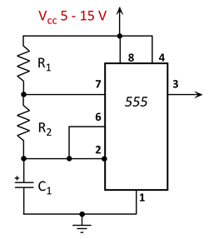

This does not fulfill the requirements stated above, which mandate a duty cycle from 1 to 100 %.
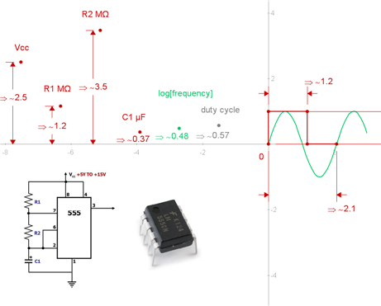

It turns out that the duty cycle can be reduced below 50% by adding a signal diode (1N4148) in parallel with R2. This was confirmed by simulation here:
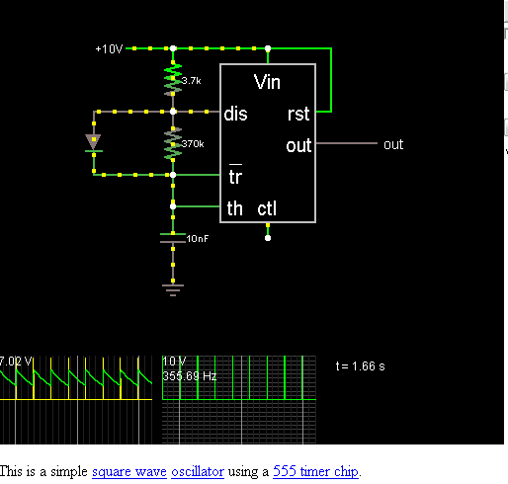

This is a trick that not everybody knows; the TI literature for the TLC555CP makes no mention of it, but does say that reducing duty cycle below 50% is difficult.

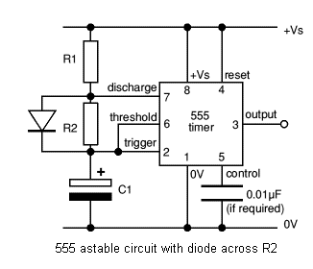

The specs of the specific low power 555 state the power dissipation is the same. (600 mW) but that the 0.1-μF capacitor at CONTrol in the figure below decreases the period by about 10%.
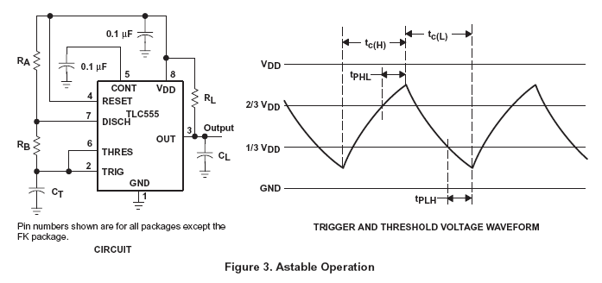

Filter then amplify, rather than the other way round!

Filter the output using a low power, low pass filter and then drive an FET to minimize power consumption.

You don’t’ want to put out a powerful square wave and then throw energy away by filtering out the higher power harmonics.

It might be good to use the signal at pin 2, rather than the pulse train, because less filtering will be required.

But this will interfere with good control of the duty cycle, so it is probably best to use the output, drawing as little current as possible, filtering that, and then amplifying the result.

The FET is required if the power exceeds 600 mW and if the current exceeds 100 mA.

LEDS

The target LED’s are Nichia NS6W183E (blue bag) that can handle 900 mA pulsed and dissipate 3200 mW between 3.5 and 4.0 Volts.

So clearly, an FET is needed. Also, work within margins that extend the life of the LED.

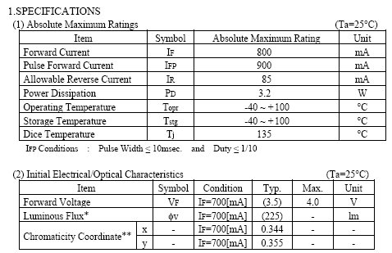
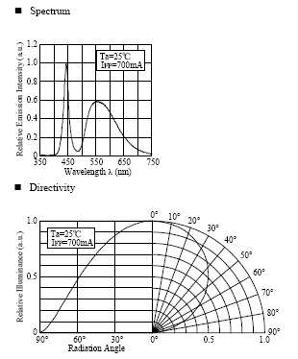

The alternate is the Nichia NJ5W036LT (pink bag) that can handle 900 mA pulsed and dissipate 2500 mW between 3.3 and 3.85 Volts.
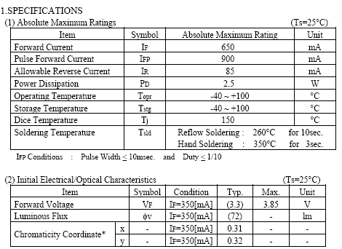
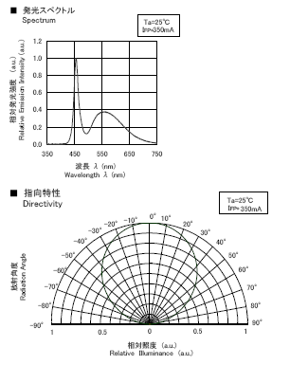
Additional LEDS may be selected here. Use the pull-down panel, as that one page is limited.

Contact for these parts is Kevin Lemery [Kevin.Lemery@FutureElectronics.com] who is the Avado Rep (they carry Nichia).

Construction Considerations – The “Do” Phase

Construct the unfiltered version first. The rationale being that at extremely short pulse widths now available that filtering will matter less since it becomes biologically impossible to accommodate to the pulse. The diode-corrected circuit has strobe capability, which is quite interesting.

Also, the duty cycle is now variable from 0 to 100% with the signal diode in place. This is just great!

Changing capacitance allows frequency change without a change in duty cycle.

Changing R1 changes t1
Changing R2 changes t2 similarly.

Controls are now orthogonal. Perfect!

1) EXPERIMENTAL ACTION: Once the prototype is built, measure the power consumption at various settings. Measure light output with solar panel.

2) EXPERIMENTAL ACTION: See what effect strobe rate has on bugs while riding. Is there a magic frequency for various bug and bird species?

3) EXPERIMENTAL ACTION: Highest flashing rate (assuming FET can switch rapidly) is 2.1 MHz flashing frequency. Measure with solar panel and see if these high frequencies are reachable.

If a capacitive array is used, 200 pF is the smallest unit of capacitance that need appear, excluding lead or package capacitance.

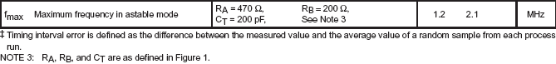

Further Computations, Next Steps

HUMAN INTERFACE COMMENT:
It would be really interesting to allow the user to be able to easily change R1, R2, and C1 while riding and explore fine tuned ranges or
Synchronize them interactively. For example, synchronize them with the rate of turning of the bike wheels to make the bikes stand still.
This is getting a very primal signal feeling.
Examine the frequency response of the LED’s and also the measuring equipment for characterizing the flashes, like the solar panel.

EXPERIMENTAL HYPOTHESIS:
The most perceptually interesting pulse configurations will occur on sweeps near:
  - flicker fusion rate: 10 – 60 Hertz
  - characteristic brain wave frequencies
  - strobe or motion freezing frequencies.

Sonic mappings will be very useful for being able to reproduce key frequencies.
It will be interesting to let the user set a gross frequency domain and then bend the frequency interactively under fine control with pitch feedback.

1) SIMULATION ACTION: Now that controls are orthogonal, spreadsheet the relations to determine plausible value ranges for R1, R2 and C1

SIMULATION RESULT: This action was completed. The results are summarized below.

SPREADSHEET RESULTS TO DETERMINE PARAMETER VALUES:
  - R1 controls T1
  - R2 controls T2
  - C1 controls ONLY FREQUENCY
  - R1/(R1+R2) controls duty cycle
  - For strobing pulses, very short duty cycles are necessary. This requires a large value of R2, on the order of the maximum value of R1
  - Response to changes in R1 and R2 are sigmoidal on a log-linear (x-y) curve
  - Log taper pots are required with responses drawn from the curves below.
  - Log taper pots come closest to linearizing the response and allowing the exploration of the maximum number of frequency ranges.
  - Most of the change occurs for a 10K pot.

Here are component sizing results for the high frequency (200 pF) case:
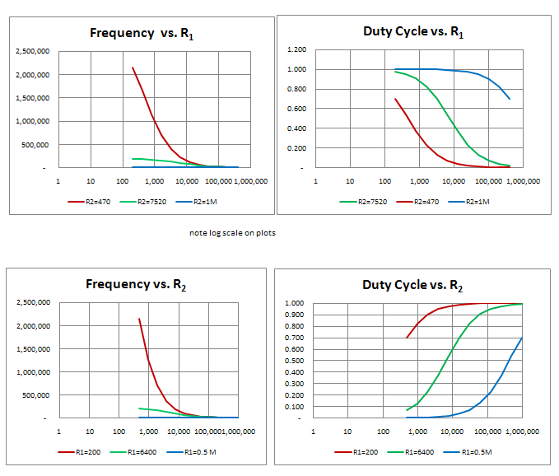

Here are component sizing results for the low frequency (100 uF) case:

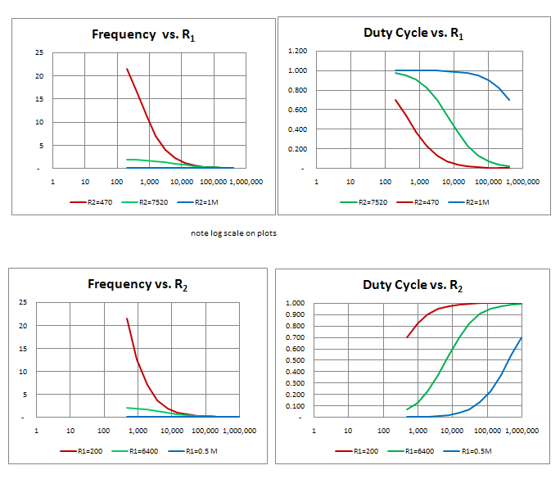
It becomes evident from the plots that one is trying to control frequency and duty cycle, 2 parameters, with three controls. Although capacitance does not affect duty cycle, it DOES affect frequency.

Two Knobs Control Three Parameters

So it would be nice to set up two controls to control the three parameters such that one control would be frequency, and the other would be duty cycle.

What would that look like? Is the three-vector parameter set unique? Or are there more than one set of three parameters that produce a given frequency and duty cycle?

SIMULATION ACTION: Find two controls, frequency and duty cycle that will control the three parameters, R1, R2 and C1.

SIMULATION RESULT: This action was completed.

The solutions is:

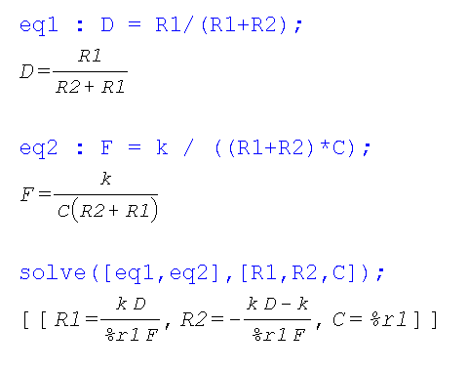
Therefore, here is what must happen. User selects frequency F and duty-cycle D.

a) Capacitance is chosen that is compatible with this frequency of operation.
User dials in frequency by setting capacitance via coarse and fine-tuning.
b) R1 is solved (k = 1/ln(2)) based on the settings for D and F.
c) R2 is solved

The circuit is configured with these values and operated. The inversion, summing and differencing operations can be done with operational amplifiers. This previous link is the java simulators.

Multipliers can be used to implement these operations also.

Note that the denominators is the same for R1 and R2, which means it only needs to be computed once.
Node that the kD term recurs and the multiply only needs to be done once. Four TI multipliers should be sufficient.

The trick is to do the math in voltage space, and then convert the voltage to a resistance using an FET with the technique described here. Some voltage scaling using voltage dividers will be necessary. This should not be too difficult. The trick will be to set the resistance values as high as possible to reduce power consumption, but not so high that excessive noise is introduced.

DESIGN ACTION: Compare and contrast the use of a low power microcontroller in concert with digitally controlled potentiometers as opposed to analog expression evaluation.

Capacitance/Frequency would still be manually selected. Could use your switched capacitor idea.

BUILD ACTION: Might be good to build this in stages, so that you can get a version lit up with just variable resistors and fixed capacitors, plug into breadboard style.

2) SIMULATION ACTION: Use TINA-TI to confirm the performance of the circuit, including the FET. The diode can be a dummy load, since characteristic matching will be difficult and time-consuming.

3) SIMULATION ACTION: build a circuit using the java simulations that implement the expressions for R1, R2, and C. confirm operation in TINA-TI.

BUILD ACTION: build the thing in prototype, using a low power LED for safety, appropriately compensating for component characteristics.

EXPERIMENTAL ACTION: Measure the output of the LED using a solar array.

PRELIMINARY RESULTS:

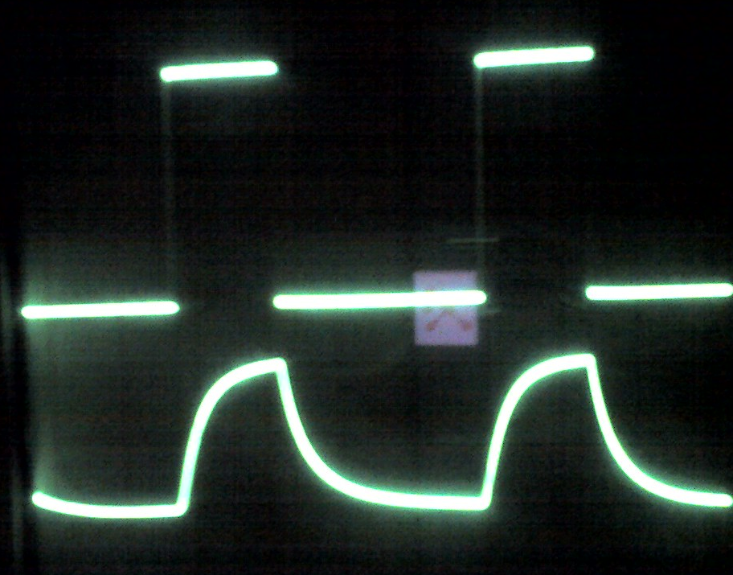

The top trace is the output of the 555 to the Nichia high brightness LED.

The bottom trace is the output of the solar panel that the LED was illuminating.

Test took place at low acoustic frequencies, on the order of 100 Hz.

Notice how the solar panel cannot respond to an instantaneous change in brightness.

It tends to integrate, or low-pass filters its input.

It is interesting that the eye has the opposite response.

The eye tends to differentiate or high-pass filter its input, thus the problem with aliasing.

EXPERIMENTAL ACTION: Use a thin film solar cell and see if you obtain the same result.

Done. Rise time is faster than fall time with the thin film solar cell.

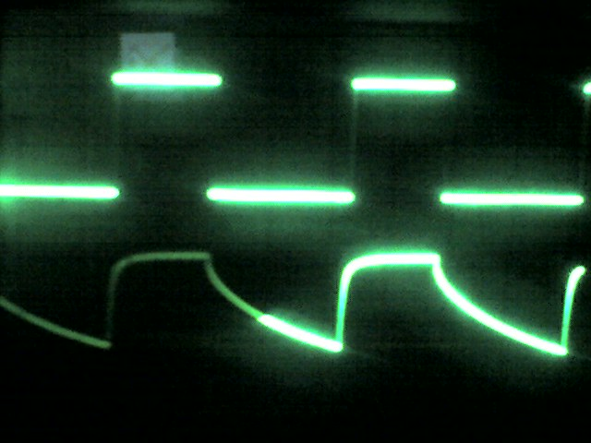

Inquiry to International Rectifier for Solar Cells led to discovery of Texas Advanced Optoelectronics. They make light to voltage and light to frequency converters.

EXPERIMENTAL ACTION: Use the solar cell and high intensity LED combo as a sound effects.
1) build amplifier to convert voice on musical signal to modulated LED.
2) pick up light signal and use distance, angle and gel filters to affect waveform interactively.

EXPERIMENTAL ACTION: Get the charger working and battery pack assembled.

1) Done. Photo

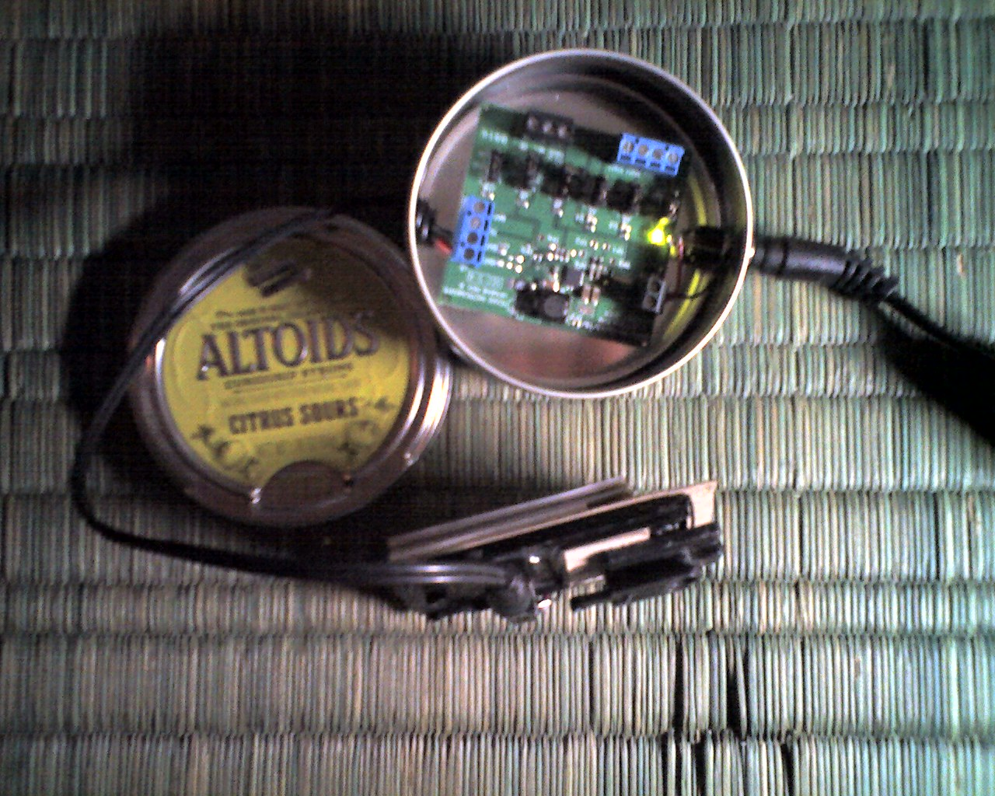
By placing a gel between a high intensity LED and a solar cell I have found that I can selectively filter the waveform.
This could be useful in a sonic device where a performer wishes to sculpt the sound by changing its intensity of frequency response.
It has the advantage, unlike DSP, FPGA, or FFT algorithms of being REAL TIME. It may have other uses as well.
This is a private disclosure.
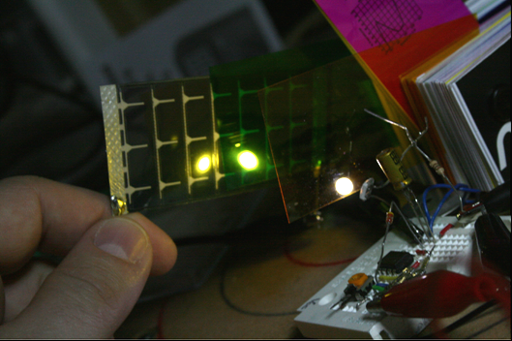

The bottom waveform is the BEFORE, and the top waveform is low pass filtered, AFTER passing through the gel.
The low pass filtering occurs without the gel, but the waveform can be further contoured by gel selection as Naomi witnessed this morning, October 30, 2009 at 11:30 AM.
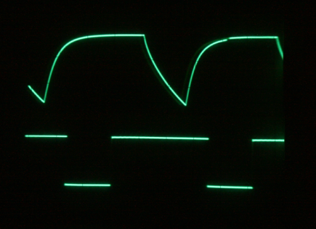

I was just trying to build a better bike light. This always happens to me and I would just like to get one thing done before I get distracted by another.

ADD – such a blessing, such a burden!

DESIGN ACTION: Design a photo postcard for this circuit and send for printing.

First Build – Assumptions and Results

A first build was conducted [photograph the rig] that had the following results.

DESIGN ACTION: Add a transitor capable of being switched on by the 555 that can sink up to 3.5 watts of power. Since the high intensity LED is running about 7.4 V, that requires 466 mA, or about ½ ampere of current during turn-on.

PART SEARCH ACTION: Review available parts for ½ ampere, 7.4 V capability.

CANDIDATE PART: Phillips 2PA1015 on bicycle light is a PNP general purpose transistor.
Part has 150 mA capability. REJECTED.

CANDIDATE PART: Phillips 2PA1015 on bicycle light is a PNP general purpose transistor.
Part has 150 mA capability. REJECTED.

One of the issues is whether to use a bipolar junction transistor or an FET to do the switching.

FET is a voltage-controlled device, and therefore uses less power.

BJT is a current-controlled device, so there must be current flowing for the gate to be open.

Bottom Line: N-channel MOSFET can be used to turn any DC powered device on and off.

The N-channel MOSFET is quite easy to work with:

Excerpts from http://www.youtube.com/watch?v=Te5YYVZiOKs

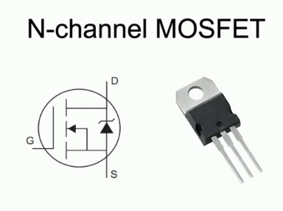

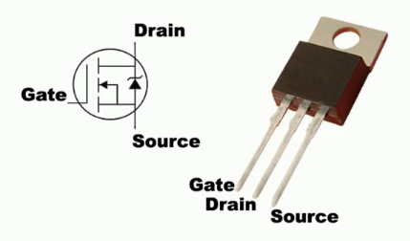

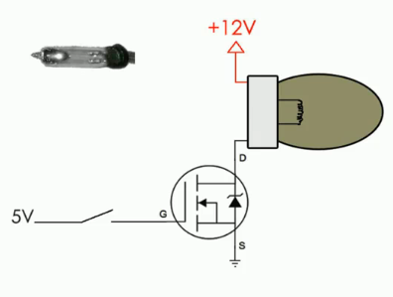

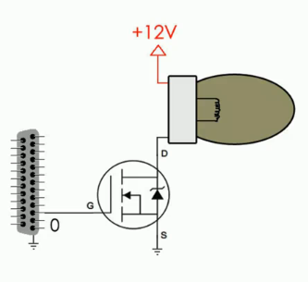
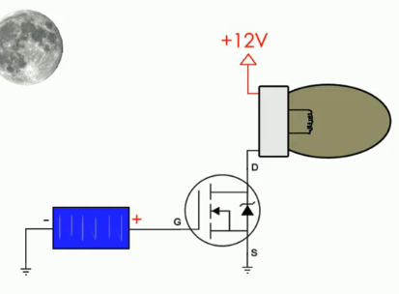
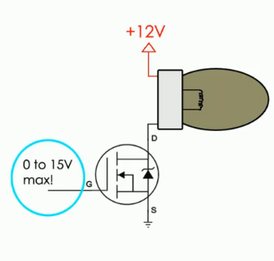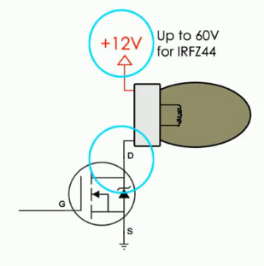
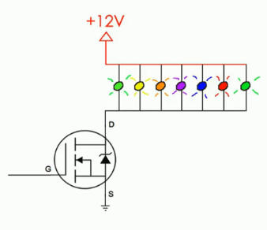

Motor / Solenoid
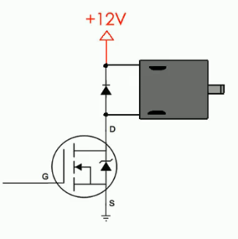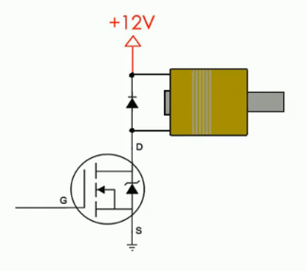

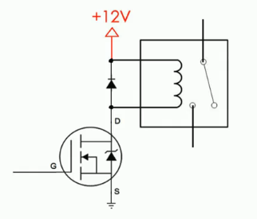
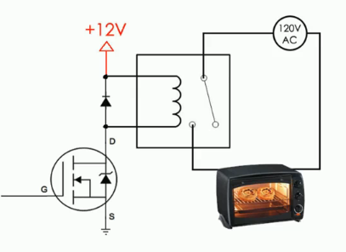

NPN BJT biasing
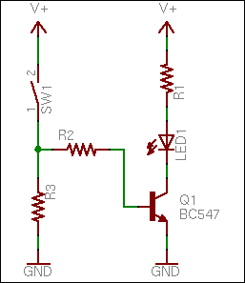

PNP BJT biasing – “flipping” the circuit.

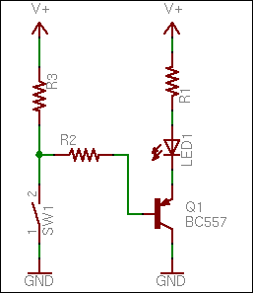

Perfect Candidates for Paper Circuits

Left: Showing effect of variable resistance between base and collector and consequent gain.

Rite: Showing product gain of Darlington Pair, requiring only touch conductivity to bias.

( I think these are both common collector configurations, one could use LED’s instead of LAMPS in the paper circuit.)

Note that if R on the left is a light senstive resistor like a cadmium sulfide cell, that exposure to light can activate current flow. Also a novel paper circuit.
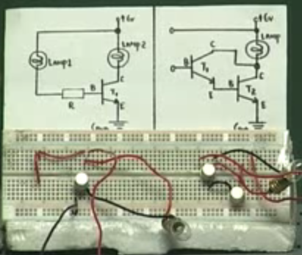

Simulation of Darlington Configuration is useful, but probably more expensive to generate (authorware was used for this demonstration) than a paper circuit, although one must compare reproduction costs.

The advantage of the paper circuit is that it can be directly incorporated into circuits of more complexity without an increase in simulation time. Of course multi-core mitigates this somewhat.

To study the Base-Emitter Junction of a BJT, it is just characterized like a diode. Beyond .4 V biasing silicon diode or 0.65 V biasing silicon transistor or .1 - .2 V biasing germanium transistor, there is a large increase in the current with no concommitant increase in voltage. Vbe is the base emitter voltage. Below is the common emitter configuration. Previously we showed the common collector configuration.
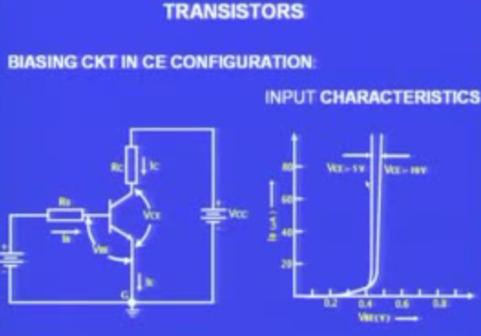

Abbreviations

TO- case designations stand for Transistor Outline

Common Emitter CE configuation is the “most useful” configuration in transistor applications.

The graph below shows the two operating regions.

In the linear region, the transistor can be used as an amplifier.

In the flat regions it can be used as a switch.

Beyond the flat region the junction melts because of excessive current,
Though one might wonder what supercooling might do in that region.

Also, could it be that “hole” or electron vacancy flow is analgous to positron flow.

Could one make a solid state device from a positron source?

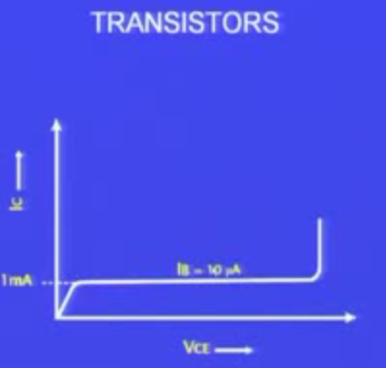

The more general case is shown here for various biasing cases as a surface:

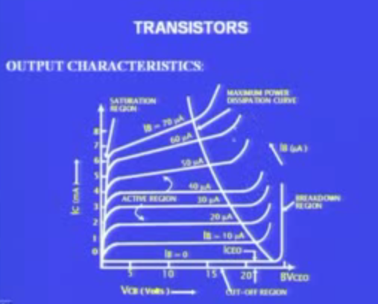

Since these operating regions constitute maps of how to proceed, could one create a microprocessor controlled device to determine which region one is operating in, using small microcontrollers.

See for example, Afroman’s discussion of a digital capacitor. Examine the pros and cons of such a device, especially its switching speed.

Transistor must be biased before operation, or better said, bias determines the nature of the operation.

See this series of lectures.

Also see digital capacitors here.

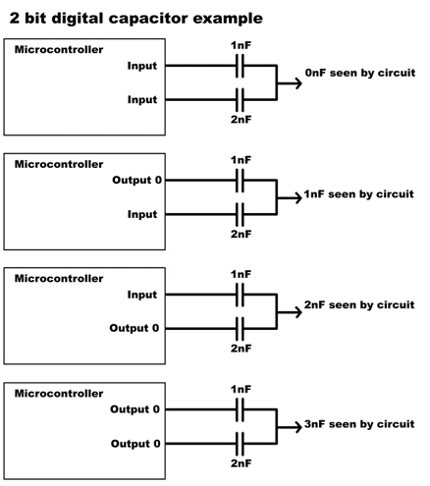

This has become a dual document of sorts. It describes work on the vFlasher™ which is underway and also on the OSP development I stumbled upond while testing the vFlasher™, which seems worthwhile.

DESIGN ACTION: Set up a source that takes a musical or tone generator or electric guitar feed, modulates the LED with it, and then receives it on any one of a set of optical sensors and then demodulates the optical sensor to produce a tone that can be heard through earphones or over speakers. Then introduce 2 color filter wheels, each identical, but independently rotatable that include gels selected by a minimal spanning method along with a clear optical path with no gel.

Then by adjusting the positions of the color filters, change the tone. It is really a color tone circuit.

DESIGN ACTION: Determine an appropriate subset of the ROSCOLUX filters by finding an orthogonal subset.

There are 224 filters, so we might cut a 256 slot wheel. But if we were to cut a 128, 64, 32, 16, 8, 4 or 2 color wheel, which filters would we choose that are the most orthogonal to each other?

This is easy. Just perform the 224 squared dot products and find the angle between each pair of filters. Then plot the angles and look for clusters. How do you cluster these mathematically? Find them and identify which filters are closest to the mean of these clusters. It is some kind of recursive grouping algorithm.

Then design a compact 32 hole filter wheel and try different combinations of colors to filter the sound.

Note that both the receiver and the emitter should be easily changed so that different combinations can be tried out.

This graph shows that the energy of a red photon is about 2 eV and a blue photon is about 3 eV.
It also shows interesting solar luminance relationships for exoatmospheric and endoatmospheric illumination.

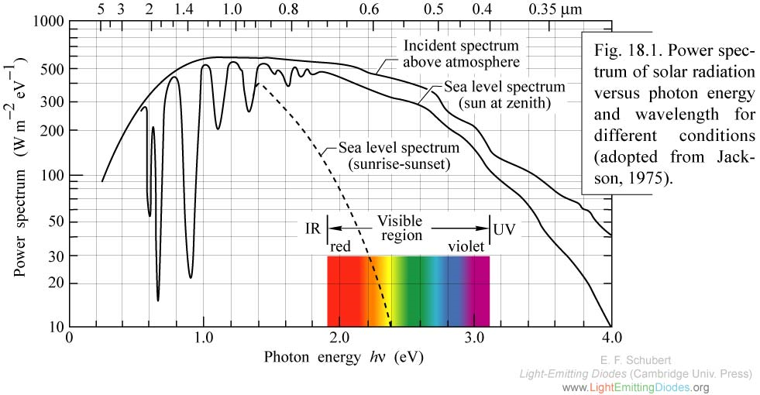

This graph showns absorption for amorphous silicon (PowerFilm?) to first order, the response is relatively flat, but favors blue as one might expect.

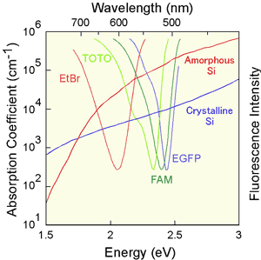

Extinction coefficient for amorphous silicon, again relatively flat in optical band.

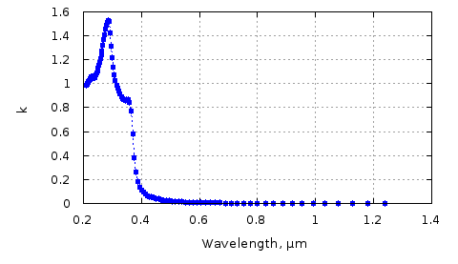

For the Avago ASMT-JW31-NTV01, 95 lumen LED, we can pump 800 mA pulsed and 350 mA continuous at a potential difference of 4 volts across the LEDS.

The question is what current limiting resistor do we need, and what circuital configuration of the high intensity LED’s makes these voltage and current conditions simultaneously true?

As a first approximation we run standard LED’s using the two cell lithium source (AvagoCurrentLimitingResistor1):

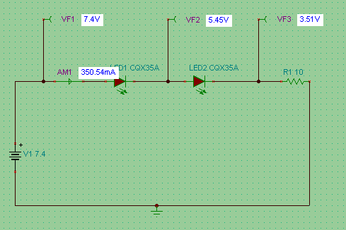

Figure -

In this case we note that we meet the continuous current requirement, but that the voltage drop across each LED is 1.95 volts. This barely exceeds the forward voltage of the diode, and so can not be expected to produce adequate brightness performance.

In the next case we substitute the LED’s with their equivalent resistances in the forward conducting direction. This equivalent resistance is computed as 4 volts divided by the 0.8 A maximum pulsed current to give a value of 5 ohms.

Running the simulation this way produces (AvagoCurrentLimitingResistor2):

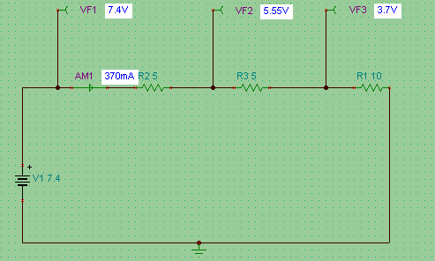
With a 10 ohm current limiting resistor we again match our current goal, but again miss the potential difference goal fo 4 volts, with each LED only seeing a 1.85 Volt voltage drop.

However, this confirms that our equivalent resistance model is valid.

Next we attempt a parallel topology, using independent current limiting resistors, due to the well-known problem of competing diodes in parallel (AvagoCurrentLimitingResistor3):

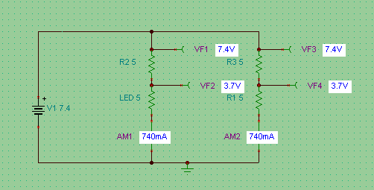

Now we are exceeding our steady state current by a factor of two, but achieving an acceptable voltage drop of 3.7 V, both the nominal drive voltage of the LED which matches the source voltage of the lithium battery.

This suggests returning to the original configuration using two LED’s in series. Each LED then serves as the current limiting resistor for the other. Now instead of wasting energy heating the resistor, we are improving the efficiency of the circuit from 34 to 68 percent. Now the internal resistance of the MOSFET will be 0.6 ohms. Including this gives our final configuration with a voltage drop of 3.5 volts per LED and a current of 700 mA.

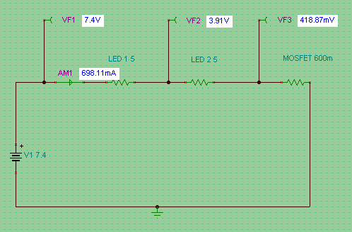

So pulsing will be necessary. To prevent the duty cycle from being too high we can raise the value of R1 if LED failure becomes an issue. The curves for this diode show that it has an equivalent resistance of 10 ohms, which will limit the current to 350 mA, in spec for continuous operation, especially considering finite battery life. Power = 2.6 watts and intensity = 190 lumens. Quite bright! The 3 lead MOSFET is rated to 20 watts, and thus can be run without a heat sink.

Exploring the State Space of Frequency and Duty Cycle

Further exploration of frequency and duty cycle variation with R1, R2 and RC.

Previously we obtained the result that [R1, R2]:

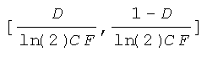

We would like to know the rates of change of R1 and R2 with frequency so we differentiate to obtain:

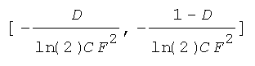

We would like to see the variation of R1 and R2 and their related rates in state space so we use GX™ to obtain:

We observe:
- The [R1, R2] relation is linear in duty cycle D,
- The [R1, R2] relation is very non-linear in frequency F. The curves are both hyperbolic.
- A 50% duty cycle makes the derivative curves identical.
- Above a certain frequency, set by C, large changes in F produce no change in [R1, R2], who tend to zero.
- Below a certain frequency, set by C, large changes in [R1, R2] who tend to $∞$, produce no change in F.
- MOST NOTABLY, when [R1, R2] change inversely simultaneously, sharing a common linear potentiometer, the most effective change in DUTY CYCLE occurs.
- When [R1, R2] increase simultaneously, the most effective change in FREQUENCY occurs, traversing the knee of the curve.

One would want to design nonlinear functions for [R1,R2] that flatten this knee for simultaneous increase or decrease of frequency and resistance.

So, for a given frequency range set by C, we would like to accomplish two contradictory goals.

We would like to continuously vary duty cycle by using a common potentiometer.

We would like to continuously vary frequency by using two potentiometers slaved to the same shaft.

The open question is whether this is possible. For example would connecting two potentiometers in parallel accomplish this goal?

This goal cannot be accomplished and here it why.

Map [R1,R2] to the rotation of a pair of knobs.

Continuoulsy varying duty cycle corresponds to simultaneous OPPOSITE directions of rotation.

Continuously varying freqency corresponds to simultaneous SAME directions of rotation.

Thus the two goals contradict.

Thus to accomplish this goal, you will have to abandon the 555 timer.

Also it would be useful to display to the user two numbers, the duty cycle and the frequency. In the act of displaying these numbers these issues will reappear.

If you use a microcontoller, you immediately discretize the frequency and duty cycle state space, losing the ability to do an exact interactive analog match.

One solution would be to look at the internal workings of a 555 timer and see if another configuration supports the desired capability, independent variation of frequency and duty cycle. How does a frequency generator do it?

Try system on a chip! You have the sample kit.

From a design point of view, I would allow discretiziation of the duty cycle as long as the 0 to 1.0 cycles were acheivable.

Discretization of the frequency would be acceptable if it were less than .025 Hz over the frequency range of interest.

This circuit with a different capacitor, and possibly resistor network solves the problem of independent variation of duty cycle and frequency. It comes in a quad pack, but only two of the four comparators are used. It retails for around $0.30 cents and thus reduces the cost signficantly over other approaches.

It also can be used to drive a mosfet, the taper of the parts will have to be examined by simulation.

Order bulk parts from mouser. Radio shack carries the LM339 for prototyping purposes and everybody makes them.

Simulate this circuit in the Falstad context and with Spice if necessary. Then bench it and go from there.

Analog is beautiful, so is sticking to your design goals, specifically independent variation of duty cycle and frequency. Whew.
key lesson learned.

1) breadboard all aspects before committing to a layout.

the circuit failed because you did not anticipate the load on the battery due to the MOSFET.

since this was added after breadboarding was complete, you ran into unanticipated problems.

2) YOU CAN systematically debug by checking sections of a circuit, and minimally breaking only those connections necessary to isolate the circuit at its minimally connected (I/O) points.

3) Take a break when you feel overloaded, rest and come back to it. It will be there. Don't get discouraged.

4) Google unknown areas, like how to quickly test a MOSFET.

5) you didn’t need to flip the diagram to wire the circuit.

SimpleCircuits™ - I like this name.

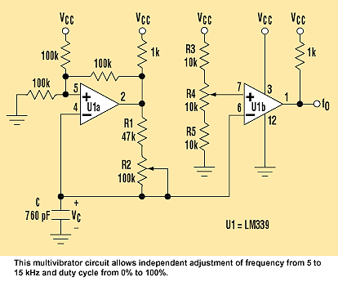

 | 4 | 100k | resistor | 1/4 | watt
 | 3 | 10k | resistor | 1/4 | watt
 | 1 | 47k | resistor | 1/4 | watt
 | 2 | 1k | resistor | 1/4 | watt
 | 1 | 100k | pot
 | 1 | 10k | pot
 | 1 | TBD | cap

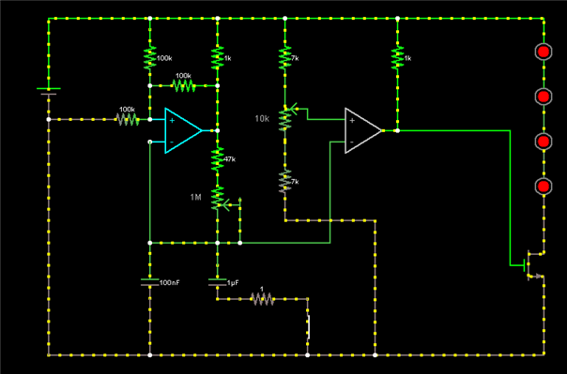

Circuit works due to advice from Falstad to make sure wires are connected node to node.

4 LED case: 132 mW of power used total.
3 LED case: 1050 mW of power used total. With 18 Ω resistor: 384 mW of power to Light, 10Ω 534 mW
2 LED case: 1336 mW of power used total. With 18 Ω resistor: 530 mW of power to Light
1 LED case: 842 mW of power used total.

TEST ACTION

See if the 3 LED case will stay cool enough in continuous duty with no current limiting resitor if so, it produces the most light. If it requires a current limiting resistor 3 LED’s cease to be competitive

I measured the VARTA batteries, the ones that charge to completion and they are 7.4 VDC nominal at full charge while connected to an 8 ohm load, with about 0.93 Amperes.

The following diagram combines the schematic, layout and simulation simultaneously:

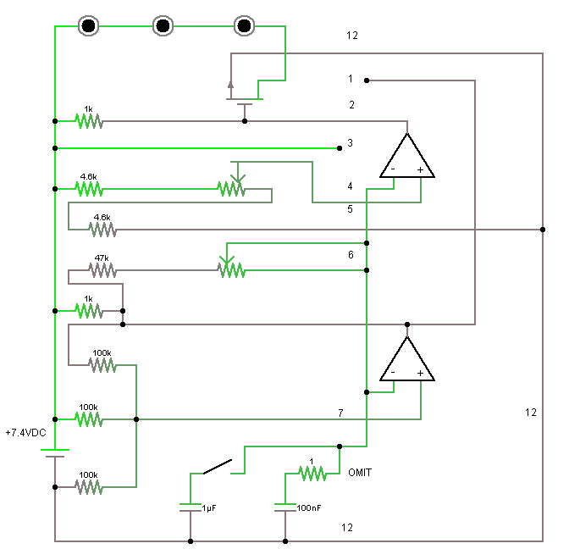

Bench Results of 12/18/2009

1) Three LED’s melt just as fast as two, so current limiting resistor is a fixed requirement.

2) Replace 47 K resistor in with 120 K resistor gives a little wider flash rate range at the expense of being an effective strobe tool.

3) Prototyping the connections is difficult on the second design, so a paper circuit is probably a better starting point on this version.

4) Which to place in production is an open question. Need to prototype the second one before making that decision.

5) Need to begin working the charger side of the issue.

