made the mistake of using the power supply 18 V unloaded instead of the battery pack 8.1 unloaded.
without a current limiting resistor this fried the array.

The 8.1 version should have been wired this way:

http://led.linear1.org/led.wiz
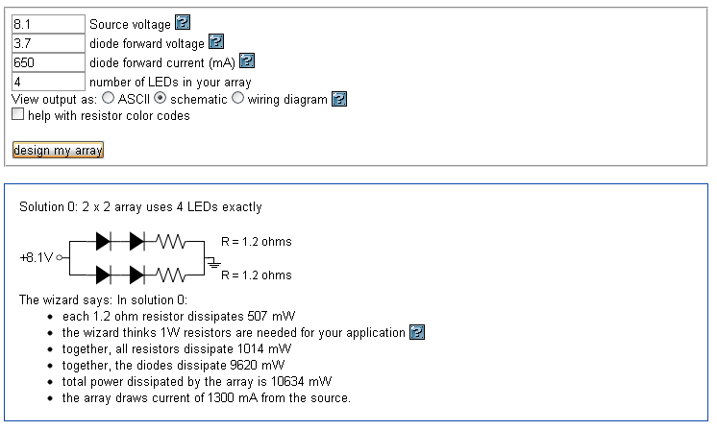

The

The 18 V should have been wired this way:

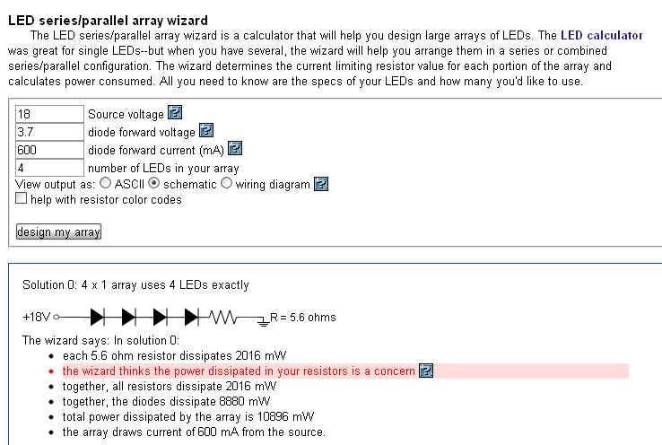

Action Items
replace the LED Array and redo the configuration.

New Design

