Phase 46 – Solar Collector Design For Garage Roof

I started with an important misconception, neglecting the 41 degree rotation of your house to the east. This turns out to be a huge problem, which I will demonstrate below.

Making single solar collector troughs integrated with the roof, requires that the house point due north (and there may be additional geometric corrections).

Considerations:

The solar collector should be inexpensive, and readily assembled from available materials using available tools.

The advent of aluminized mylar has made possible reflectors and collectors that are approximately 95%, at a cost of about twenty cents per square foot at this writing.

Original Concept:
- black tube is filament
- sun arch shows path of sun through day, thickness shows intensity.
- sky reflector texture is solar collector

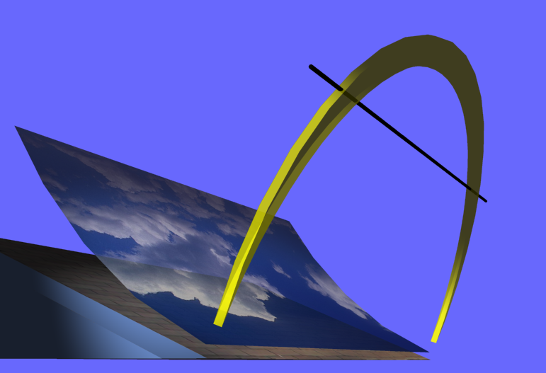

Notice that the arch leans. This lean depends on the day of the year and upon our latitude and longitude.

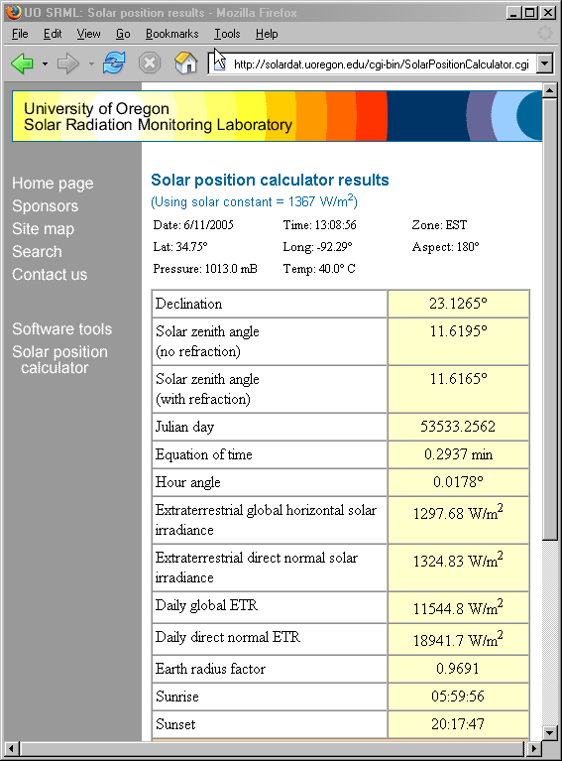

Latitude and longitude are easy:

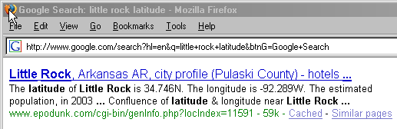

Day of the year is today. This means time is very important. Notice the calculator above said EST. That turns out to be UTC-5, which is Central Daylight Savings Time.

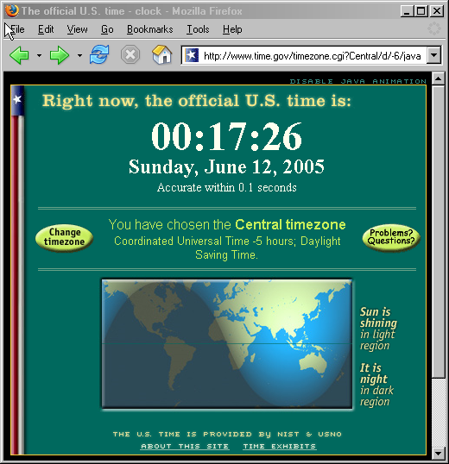

Now another important detail is the orientation of your house:

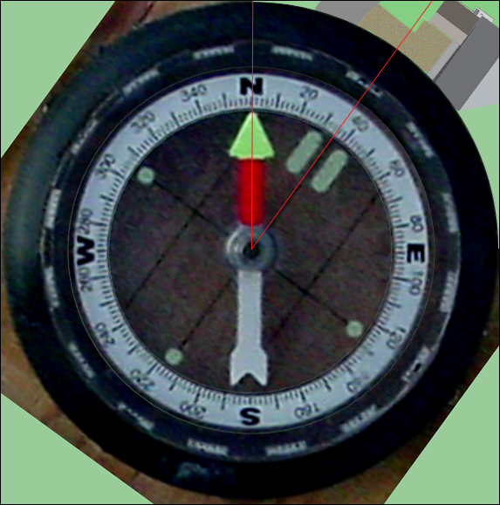

The first compass reading on site gave 40 degrees using a level for the sight line.
A second reading on site gave 36 degrees using a record cover for sight line. We average these two measurements to get that the garage is rotated 38 degrees clockwise (east) of magnetic north. But magnetic north is not geographic north, that is, the axis of the earth’s rotation.
To correct the compass reading we must consult a chart of magnetic declination:

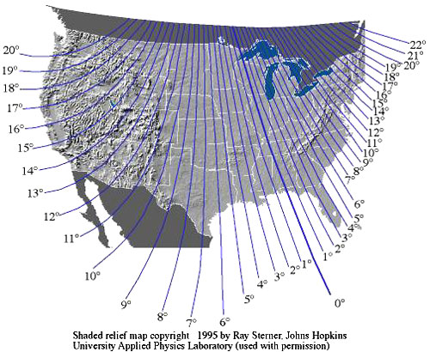

The line of zero declination runs from magnetic north through Lake Superior and across the western panhandle of Florida. Along this line, true north is the same as magnetic north. If you are working west of the line of zero declination, your compass will give a reading that is east of true north. To compensate for magnetic declination in Little Rock, AR we must rotate the compass dial counterclockwise by a little over three degrees.

Magnetic north is east of true north by 3 degrees. So adding 3 degrees west for magnetic declination says that the garage sits 41 degrees.

Therefore, your house is turned 41 degrees to the east, correcting for magnetic declination.

So this is the situation instead!

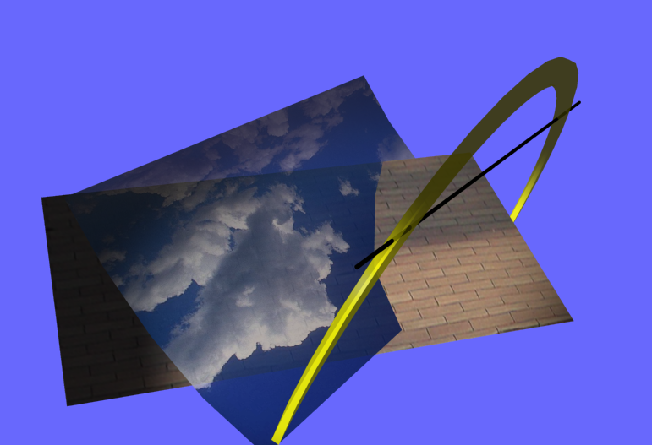

The reflector must point at the sun. We can use any section of the parabola, but the trough of the parabola must line up with the ecliptic plane of the solar arch.

We can pick up the missing corners by elevating the collector.

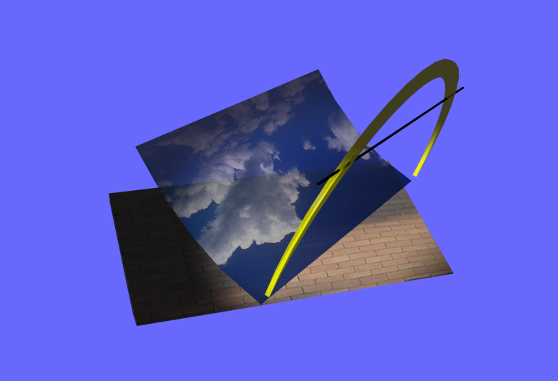

Trimming it to fit the roof produces this:

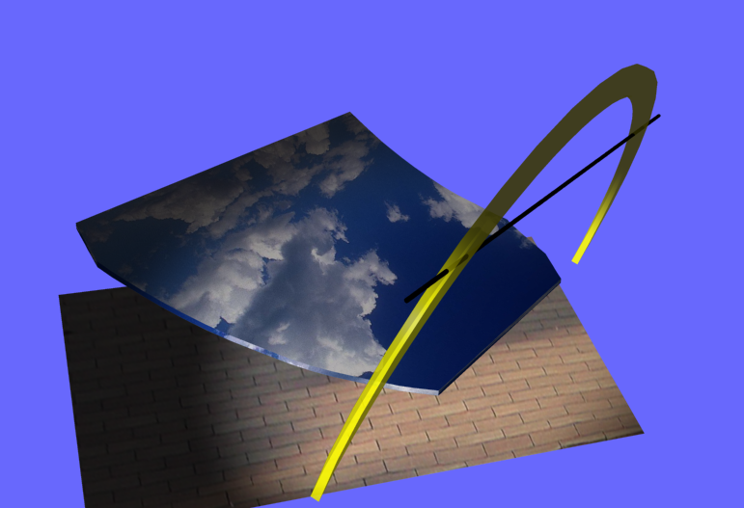

Conclusion, rotation of house makes collector design of the supports MUCH more difficult.
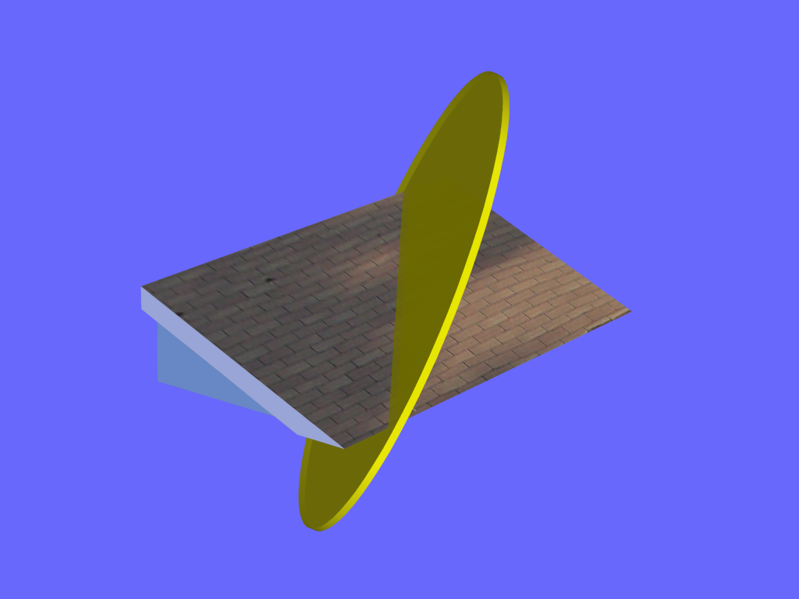

Think about that last picture. Does this seem like the path of the sun to you? I never realized it looked like this. This is what the path looked like TODAY. It was directly overhead at a little after 1 PM.

Photogrammetry Sizing of Roof

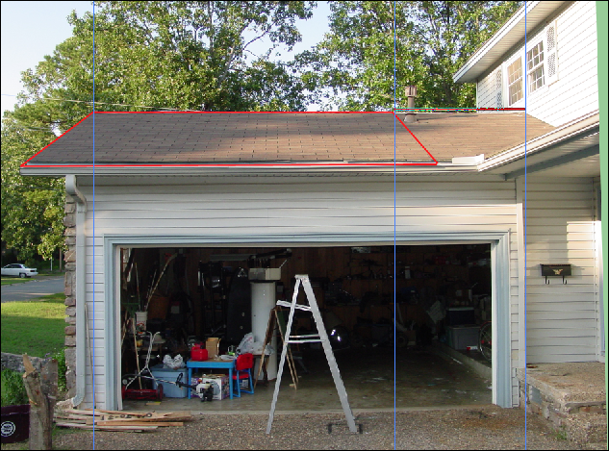

If your house pointed due north the declination angle would be 23.17 degrees. That is the “lean” angle of the solar arch.. Your roof sits at 22.69 degrees, which is exactly .48 degrees (less than half of a degree of being perfectly normal to the incoming sunshine).

I did much more work than mentioned here. Unfortunately it is probably useless.
