**A Scalable Turntable Tool for Parabolic Mirror Construction**

L. Van Warren MS CS, AE  
*Warren Design Vision  
wdv.com*

*Wednesday, February 1, 2012*

**Introduction**

The parabola is the only geometric shape that will collect incoming parallel rays and focus them to a single point. Parabolic reflectors are used in satellite receivers, solar collectors and other applications.

[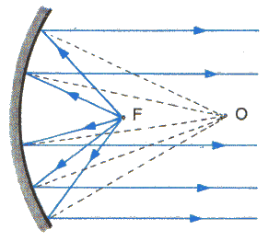](http://library.thinkquest.org/22915/reflection.html)

Construction of these shapes is often problematic and dependent upon the wavelength being focused. In microwave applications, a parabola of chickenwire can suffice, while in astronomy parabolic mirrors that are ground to 1/10th of a wavelength of light are commonplace. The visible spectrum sits between from 400 nanometers (ultraviolet) and 800 nanometers (infrared) with the mean being 600 nm (yellow). The peaks sensitivity of the eye is at 555 nm (green). For solar collectors the mean wavelength is much longer, around 800 nm.

[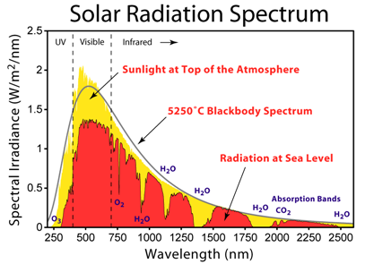](http://en.wikipedia.org/wiki/Sunlight)

Unlike their flat solar-cell counterparts, parabolic mirrors can capture a significant amount of the solar spectrum in the infrared region, where the band gap of most semiconductors forbids energy harvest. This, when combined with their high collection efficiency (over 90%) makes them an excellent addition to the solar energy arsenal.

**Turntables**

Machining a surface to a tolerance on the order of a wavelength of light (500nm or ½ micron) is out of the reach of most technologies, including CNC machine tools, due to the discrete steps of position and stairstepping artifacts that appear in the final work. However, spinning pools of liquid form a perfect parabola, and these have been used for astromomy applications for some time.

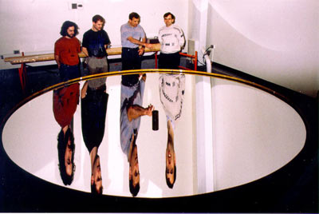

These turntables must spin at a uniform speed, typically 40 RPM. They must be very flat, free from vibration and therefore balanced. The containers that sit on the turntable must be tall enough to contain sloshing of the fluid during startup and rigid enough to prevent out of control oscillation of the kind often seen in clothes washers during an unbalanced spin cycle. The container, like the turntable must be balanced and not contain an excess of mass at any angular station.

If a spinning liquid is carefully solidified the resulting shape is a perfect parabolic form, which can be used directly, or used as a form for casting secondary shapes and molds.

**Geometric Calculations**

The focal length of a parabola is given by the equation:

$$y=\frac{x^{2}}{4p}$$

Where *p* is the focal length in a system of units consistent with the measure of *x* or *y*.

**Spreadsheet Study**

A prototypical parabolic collector three feet in diameter can collect 657 watts of power on a sunny day. The tool to make any number of these dishes is just the cost of the casting material, modeled below for plaster of paris and foam filler.

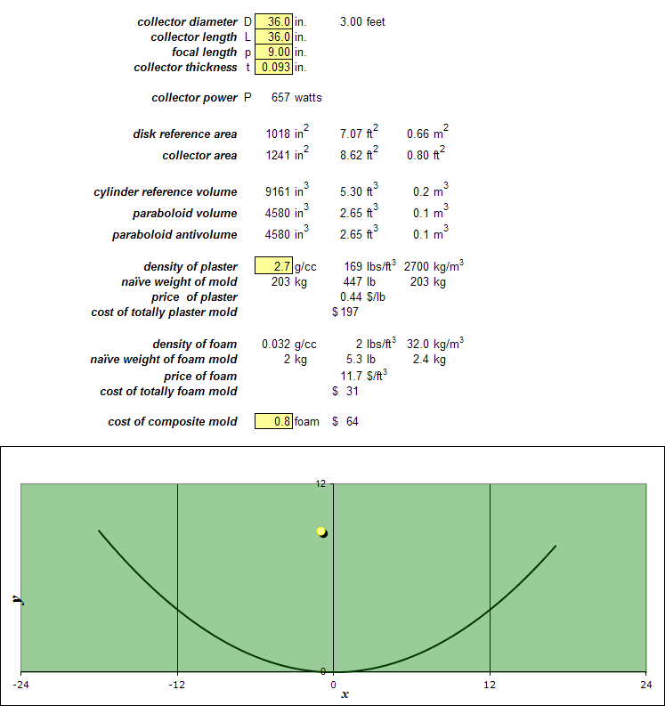

The focal length of any parabola from the square one shown here with short focus at 9" to those of infinite focal length can be constructed simply by varying the RPM of the drive from 42 RPM to 0 RPM.

**A Simple Turntable Design**

An effective turntable should satisfy the following design goals:

1. Ease of Manufacture
2. Accuracy of Dimension
3. Material Cost
4. Manufacturing Cost
5. Balance and Stability
6. Portability
7. Powered with Off-The-Shelf Hardware

A simple turntable design has been done that satisfies these seven goals. An exploded view is shown below:

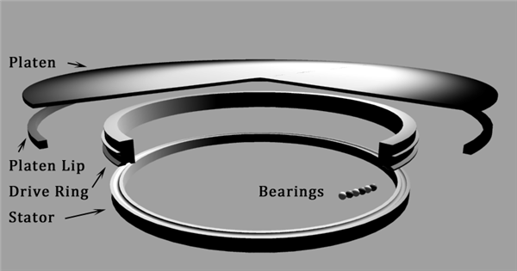

The dimensions, material specifications and weight of each piece will now be furnished in turn. All dimensions are to

0.005" unless otherwise specified.

**Platen**

The platen is a 6061 aluminum disk ¼" thick and 18" in radius. The top outside edge is beveled to 45°, with 0.0625" depth or rounded to 0.0625" radius, whichever is easier for the machinist.

The volume of the platen is 254.4 cubic inches and it weighs 24.8 lbs when finished.

The top is lightly scored with circles .016" deep, at 1" intervals, starting from the center , as a visual aid to balancing.

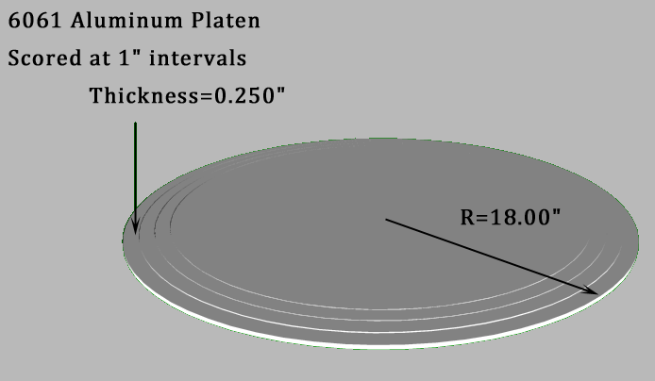

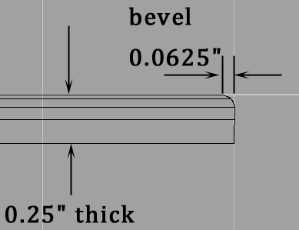

**Platen Lip**

The platen lip is a 6061 aluminum ring section 1/2" thick and 18" in outer radius. The bottom outside edge is beveled to 45°, with 0.0625" depth or rounded to a 0.0625" radius, whichever is easier for the machinist.

The volume of the platen is 27.8 cubic inches and it weighs 2.7 lbs when finished.

The platen and platen lip may be machined out of one piece of aluminum at the discretion of the machinist. This will improve balancing. It will eliminate the labor and complexity of fastening the platen and lip together but increase the cost of the aluminum stock by a factor of 4.

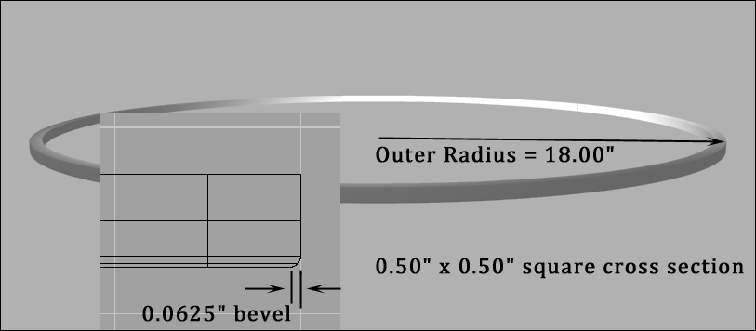

**Drive Ring and Stator (Identical)**

The drive ring is a 6061 aluminum ring section 1.75" thick, 13" outer radius, 12" inner radius with a belt flange and bearing raceway on the bottom side. The bearing raceway is for ½" DIAMETER bearings and the raceway depth is 0.125".

The volume of the drive ring is 141.78 cubic inches and it weighs 13.8 lbs when finished.

The drive ring, platen and platen lip may be machined out of one piece of aluminum at the discretion of the machinist. This will improve balancing. It will eliminate the labor and complexity of fastening the platen, lip and drive ring together but increase the cost of the aluminum stock by a factor of 7.

The Stator is identical to the Drive Ring

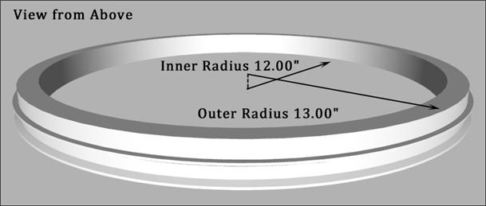

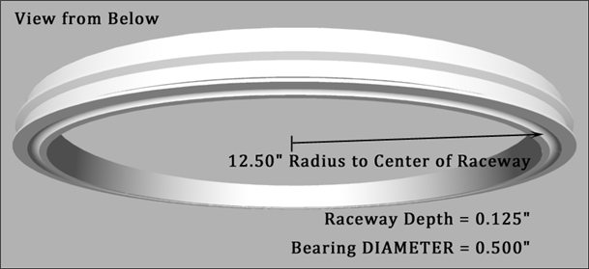

The cross section detail follows:

**Drive Ring Cross Section**

The drive ring cross section is shown below with a bearing in the raceway. Each major square is 1.000".

Each minor square is 0.250". The top lip of the belt flange is 0.125" at the outside edge.

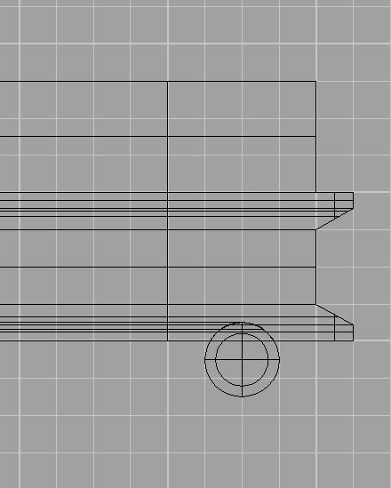

**Acknowledgements**

This work was born out of discussions with Frank and Jo Kelly, Jeanine Phelps and Lynn Mittelstaedt Warren.

Illustrations are linked to their respective sources.

© 2012 • Warren Design Vision