**Turntable Foot Description**

Notes:

* These instructions may be altered for ease of machining.
* Dimensions are 0.005" unless otherwise noted.

Material: ¾" thick 6160 aluminum or ½" thick 4130 steel or equivalent

Assume a square blank, 36" on an edge plus cutter kerf.

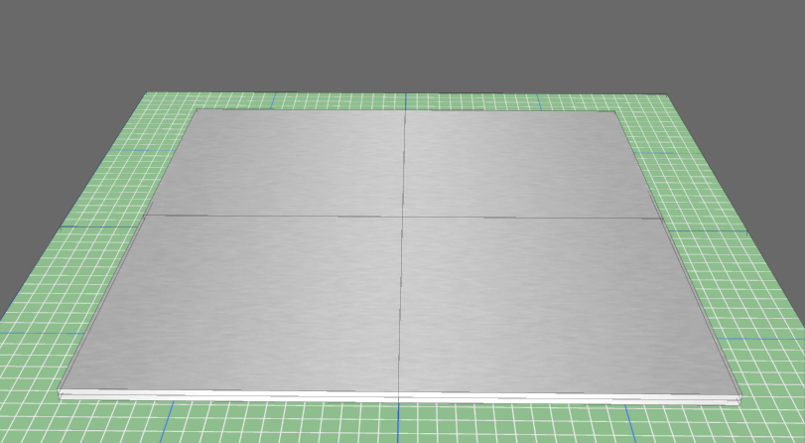

Cut 36" circle

.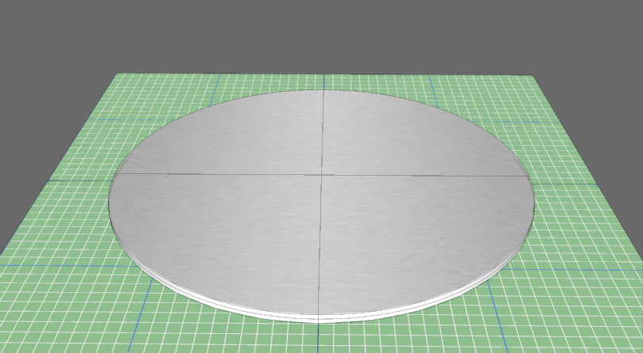

Cut center hole 2.975" in diameter.

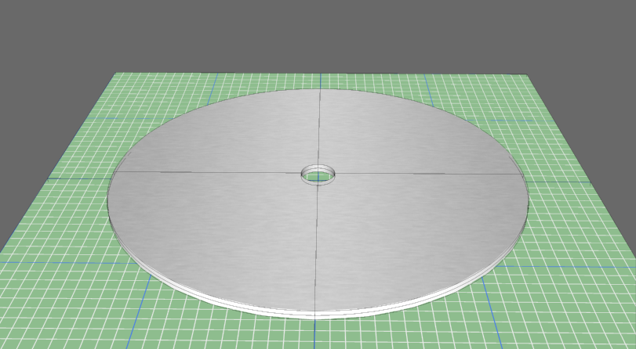

Imagine 3 copies hover with 22" between centers, spaced at 120 degrees in a perfect triangle.

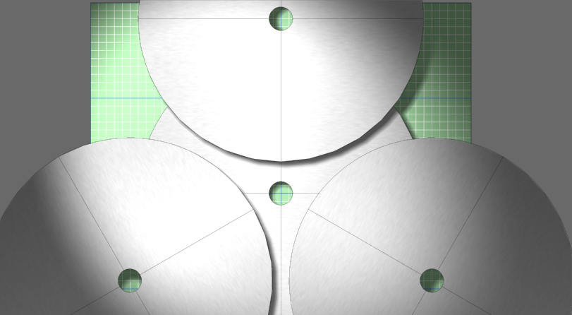

This material is removed along the corresponding arcs whose radius is 18" and whose centerpoints are 22" apart.

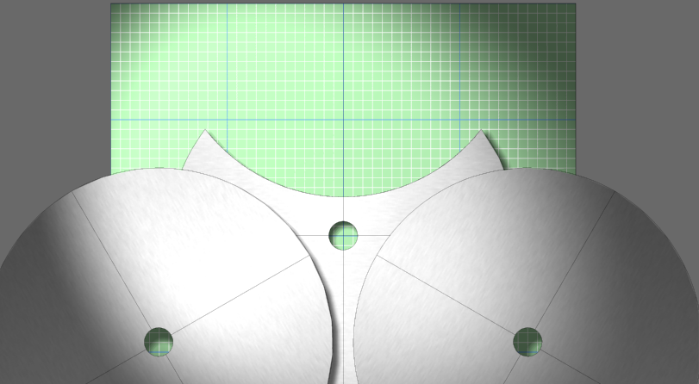

After all three arcs are cut:

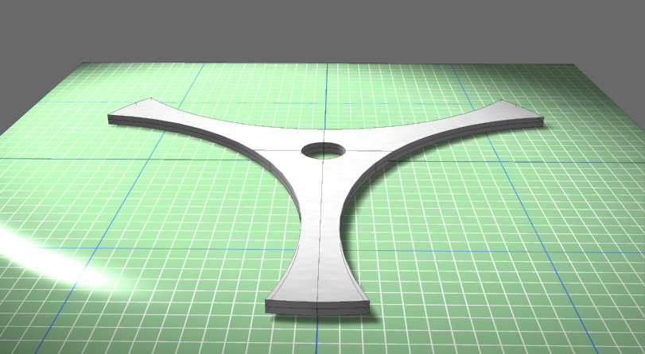

Near the center hole, drill or cut three 0.500" holes 120 degrees apart as shown.

Center to center distance is 1.895" from big to small hole.

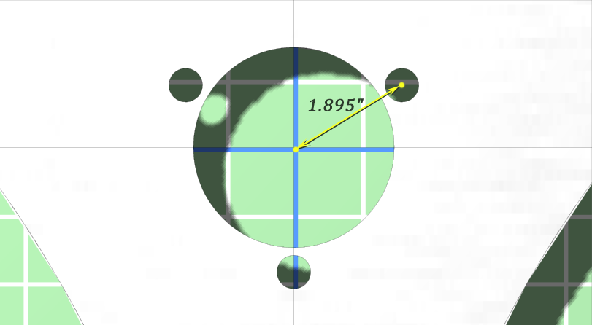

After three center holes are drilled or cut.

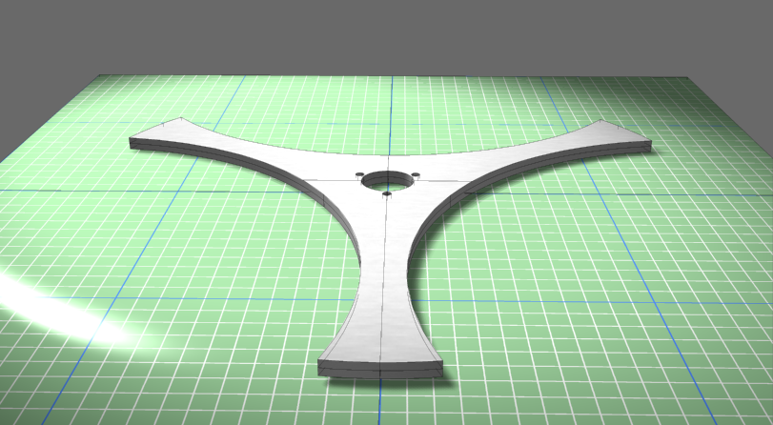

Drill two 0.500" holes on each blade at a distance of 1" and 3" from the tip:

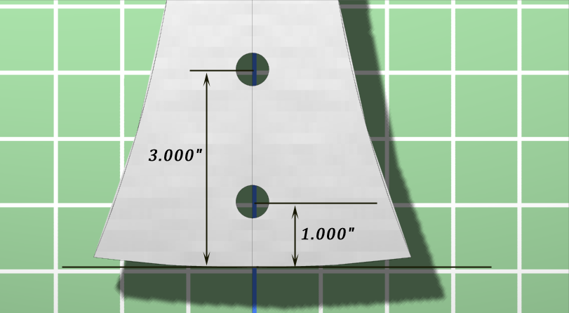

After drilling the blade holes.

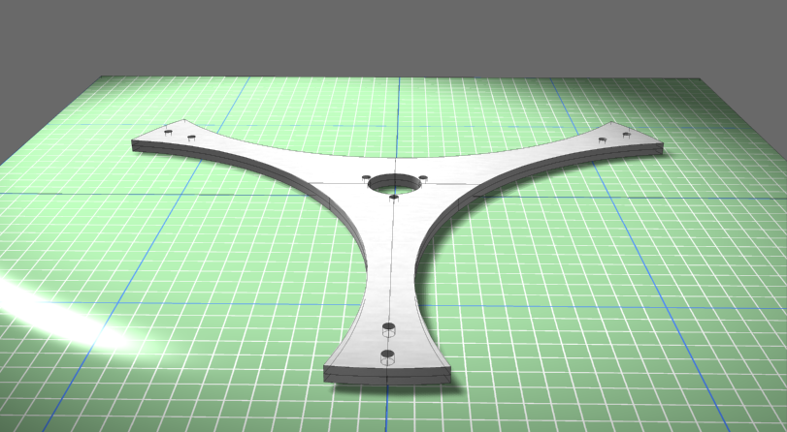

Deburr, fillet, or chamfer the 10 holes and 18 edges for safe handling and attractive appearance.

