VentureWind, Inc.

4624 Kenyon Drive

Little Rock, AR 72205

# TECHNOLOGY DEVELOPMENT APPLICATION

$60K Request

Van Warren, Designer, C.T.O.

501-664-4011 (w)

231-5426 (c)

van (at) wdv.com

Dina Nash, C.O.O.

501-246-3026 (w/fax)

479-530-8328 (c)

dina_nash (at) yahoo.com

Social Security Numbers Available on Request.

The submitters affirm the information contained herein

to be accurate and truthful to the best of our ability.

|  |  |  |
| --- | --- | --- |
| ________________ | ________________ |  |
| L. Van Warren | Dina Nash | Aug 11, 2007 |

Contents

TECHNOLOGY DEVELOPMENT APPLICATION 1

1. DESCRIPTION OF vTURBINE™ 3

2. PROBLEM DESCRIPTION 3

3. A WORKING SOLUTION 4

4. MEASUREMENT AND REAL-TIME DIGITAL CONTROLS 6

5. PRIOR ART AND PREVIOUS RESEARCH 6

6. PROTYPING PROGRAM – WORK TO DATE 6

7. OVERCOMING BARRIERS TO PRODUCTION 6

8. COMMERCIALIZATION, MANUFACTURING AND PROCESS 7

9. MARKET NICHE 7

10. IMPLEMENTATION PLAN 7

a. Timetable and Schedule 7

b. Narrative Description of Fund Use 7

c. Support Facilities, Equipment, Tooling, Personnel 7

11. BUDGET FOR PROJECT PERIOD AND DESIGNATED PHASES 7

12. QUALIFICATIONS OF PRINCIPLES INCLUDING RESUMES 7

13. ECONOMIC IMPACT PROJECTIONS 7

d. Job Creation 7

e. Export Potential 7

f. Value Added to Existing Products 7

14. INTELLECTUAL PROPERTY AND PROTECTIONS 7

g. Patents – Provisional and Long-Term 7

h. Trademarks 7

i. Copyrights 7

j. Trade Secrets 7

## 1. DESCRIPTION OF vTURBINE™

As briefed in a previous presentation, the product is a wind turbine whose design is enhanced by the use of a tensile structure. In this case the tensile structure is a venturi-shaped sail, the truncated frustum of a cone. The entire assembly including the generator is called the vTurbine™, and the sail part is, well, just the sail.

|  |  |
| --- | --- |
|  |  |
| Computer Simulation | Prototype vTurbine™ Sail |

## 2. PROBLEM DESCRIPTION

Conventional wind turbines depend on the strength and vagaries of the ambient wind for their performance. The power generated by a wind turbine grows as the cube of windspeed according to:

$$Power=Force ∙velocity=C_{p}A\left[\frac{1}{2}ρv^{2}\right]v={\frac{1}{2}C}_{p}Aρv^{3}$$

Where $C_{p}$ is a pressure coefficient, A is the swept cross-sectional area, $ρ$ is air density and v is velocity.

Wind turbines situated in low wind areas tend to perform poorly because of this. Consider for example the popular Bergey XL-1 wind turbine:

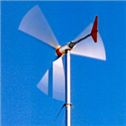

Bergey XL-1

With a blade diameter of 8.2 feet its generator produces 1000 watts at a wind speed of 24.6 mph. That same unit, when operated in the central Arkansas 7.8 mph average winds produces a mere 29 watts:

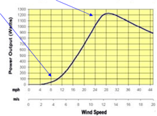

Bergey XL-1 Power vs. Wind Speed

Thus performance suffers by a factor of thirty in typical wind speeds and the equipment fails to meet expectations or achieve payback in a timely manner. This leads to an analytic figure of merit that the vTurbine™ achieves, an improvement of 31 fold - See spreadsheet below.

## 3. A WORKING SOLUTION

The Venturi Effect is well-known in engineering practice. From continuity a nozzle of varying cross-sectional area has as its governing equation:

$$ρ_{1}v_{1}A_{1}{=ρ}_{2}v_{2}A_{2 }$$

For applications that are significantly subsonic such as ours $ρ_{1}{=ρ}_{2}$ and we have:

$$v_{1}A_{1}=v_{2}A_{2 }$$

Solving this equation for $v_{2}$ yields:

$$v_{2}=v_{1}\frac{A_{1 }}{A_{2 }}=v_{1}\frac{{π{r_{1}}^{2}}_{ }}{π{r_{2}}^{2}} =v_{1}{\left(\frac{r_{1}}{r_{2}}\right)}^{2}$$

Applying this to our low-wind predicament we see that an increase in cross-sectional area produces a velocity increase proportional to the square of the ratio of the radii.

The next page shows some preliminary figures obtained for a practical vTurbine™ prototype.

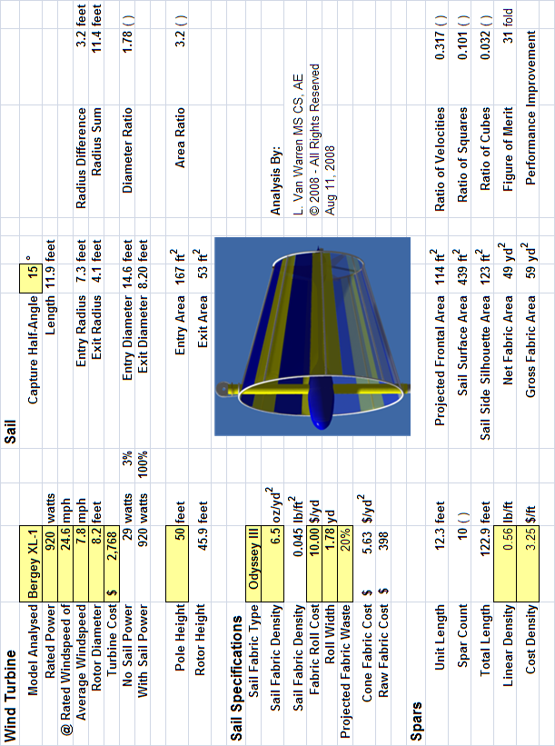

As the calculations above demonstrate a conical sail 14.6 feet in diameter increases an average wind of 7.8 mph to an average exit velocity of 24.6 mph and restores the turbine to its rated performance in low wind conditions.

In a limiting argument one might ask, why not just lengthen the blades of a wind turbine by the same amount as the sail entry radius?

The conical sail has the advantage of subtending the entire capture area simultaneously. A turbine blade, on the other hand, can only occupy a fraction of the available surface area due to its finite width. The sail magnifies velocity passively by focusing the winds of a large cross-section into a smaller one. Because fabric structures, especially tensile ones are relatively low in cost, they are a better solution – a better solution than subjecting a larger turbine to the same low winds. This makes for a more effective match of the driving force to the generator load.

***Simply adding a sail is just the beginning of our innovating process.*** We have also created an auto-reefing system, that protects the vTurbine™ installation in high winds, and weather advisory situations. A microcontroller continuously monitors the wind speed and automatically places the system in a safe configuration when necessary. This same monitoring allows performance to be optimized for a variety of conditions.

## 4. MEASUREMENT AND REAL-TIME DIGITAL CONTROLS

Besides a comprehensive performance measurement campaign that will include digital anemometers and data acquisition, we are fielding additional innovations that exploit the revolution in digital control. Real-time digital monitoring and control enable us to adaptively adjust key sail parameters that minimize loads on the tower. These innovations not only increase the patentability of the device, but aid in servicing and maintaining the unit conveniently and at low-cost. This concludes the technical summary of the invention.

## 5. PRIOR ART AND PREVIOUS RESEARCH

Four simultaneous circumstances have conspired to create a “perfect storm” for moderate-scale wind energy development and thus for the appearance of the vTurbine™. These are:

1. The availability of cost-effective composite materials such as carbon fiber.
2. The availability of low-cost digital microcontrollers for monitoring.
3. The manufacturing of high-performance wind turbines.
4. A global increase in demand for wind energy at farm, residential, neighborhood scales.

## 6. PROTYPING PROGRAM – WORK TO DATE

From the outset, an ambitious computer simulation effort was mounted to assess the cost-benefit and predict the optimal sizing of the sail with respect to specific off-the-shelf wind turbine technology.

## 7. OVERCOMING BARRIERS TO PRODUCTION

Van will fill this in.

## 8. COMMERCIALIZATION, MANUFACTURING AND PROCESS

## 9. MARKET NICHE

## 10. IMPLEMENTATION PLAN

### Timetable and Schedule

### Narrative Description of Fund Use

### Support Facilities, Equipment, Tooling, Personnel

## 11. BUDGET FOR PROJECT PERIOD AND DESIGNATED PHASES

## 12. QUALIFICATIONS OF PRINCIPLES INCLUDING RESUMES

## 13. ECONOMIC IMPACT PROJECTIONS

### Job Creation

### Export Potential

### Value Added to Existing Products

## 14. INTELLECTUAL PROPERTY AND PROTECTIONS

### Patents – Provisional and Long-Term

### Trademarks

### Copyrights

### Trade Secrets

Financial support

Attached Documents – List

a. Phase 1 and Phase 2 Financial Spreadsheets

b. Design and Analysis Spreadsheets

c. Photographs and Test Results

5.3 MARKET NICHE

1. Specific customer needs the product satisfies:

The vTurbine fills the niche for a device which augments the effect of low wind conditions when wind energy is desired as part of the mix of energy sources for a business, farm, or residence. Customers need effectiveness,

reliability, reasonable pricing, servicing convenience and low cost of maintenance, eye appeal, a way to protect the device from winds too strong, and

to do this, VentureWind will assemble and install the whole system, connect it to the electric grid, and warranty it for parts and labor.

2. Will the market support the product?

Yes, we think so, since we are the only product which purports to have so many advantages in low wind conditions.

Wind energy is one of the two fastest-growing sources of energy in the energy market today. Along with solar energy, wind systems are in increasing demand worldwide, especially in places such as Denmark, Germany, Spain, and enlightened states such as California, Kansas, Texas, Oklahoma, Minnesota, Washington, Oregon, etc. Just as residents of Little Rock have learned that LM Glasfiber, a Danish company, is making wind blades for large out of state wind farms, VentureWind will be making a product and a wind system for small wind applications, and the market may be largely an out of state for awhile, until Arkansans become aware what small wind systems will do for their personal and business economy.

Our product, the vTurbine, should cost an additional $1,000-1,200 cost to a wind system. It requires a slightly taller tower (60-70 ‘) than conventional small wind systems (30-50’), to take advantage of the higher wind velocities above the trees. The tower will be a little more expensive, as will the device that raises and lowers the turbine. However, our calculations are that the cost of the refinements we are making will lower the payback period from 10 years (in the current Arkansas incentive climate) to 2-3 years, which lowers total costs.

3. Who is the competition?

4. Does the product, process, or innovation provide a competitive edge?

5. Is there adequate financial support?

6. Does the budget support the implementation plan?

7. Is the commercialization plan valid?

8. Can key personnel support the project?

5.4 ECONOMIC POTENTIAL

1. Will the product impact Arkansas’ economy?

2. Does it have job creation potential?

3. Does it add value to existing products?

4. Can it be exported?

5.5 PATENTABILITY

1. Has a patent been applied for?

2. Are there similar patents granted?

3. Can the concept be protected by a patent?

1.0 PROGRAM DESCRIPTION

2.1 TYPE OF AWARD

2.2 DEFINITIONS

3.0 ELIGIBILITY

3.1 CRITERIA

3.2 CONFLICT OF INTEREST

4.0 APPLICATION PROCESS

4.1 APPLICATION FORMAT

5.0 EVALUATION

5.1 TECHNICAL FEASIBILITY

5.2 PRODUCTION FEASIBILITY

5.3 MARKET FEASIBILITY

5.4 ECONOMIC POTENTIAL

5.5 PATENTABILITY

6.0 INVESTMENT AWARD

7.0 FREEDOM OF INFORMATION