VentureWind, Inc.
4624 Kenyon Drive
Little Rock, AR 72205

TECHNOLOGY DEVELOPMENT APPLICATION

$60K Request

Van Warren, Designer, C.T.O.
501-664-4011 (w)
231-5426 (c)
van@wdv.com

Dina Nash, C.O.O.
501-246-3026 (w/fax)
479-530-8328 (c)
dina_nash@yahoo.com

Social Security Numbers Available on Request.

The submitters affirm the information contained herein to be accurate and truthful to the best of our ability.

________________ | ________________
L. Van Warren | Dina Nash | Aug 11, 2007

Contents

1. DESCRIPTION OF vTURBINE™ 3
2. PROBLEM DESCRIPTION 3
3. A BETTER SOLUTION 4
4. MEASUREMENT AND REAL-TIME DIGITAL CONTROLS 6
5. PRIOR ART AND PREVIOUS RESEARCH 6
6. PROTYPING PROGRAM – WORK TO DATE 6
7. OVERCOMING BARRIERS TO PRODUCTION 6
8. COMMERCIALIZATION, MANUFACTURING AND PROCESS 7
9. MARKET NICHE 7
10. IMPLEMENTATION PLAN 7
a. Timetable and Schedule 7
b. Narrative Description of Fund Use 7
c. Support Facilities, Equipment, Tooling, Personnel 7
11. BUDGET FOR PROJECT PERIOD AND DESIGNATED PHASES 7
12. QUALIFICATIONS OF PRINCIPLES INCLUDING RESUMES 7
13. ECONOMIC IMPACT PROJECTIONS 7
a. Job Creation 7
b. Export Potential 7
c. Value Added to Existing Products 7
14. INTELLECTUAL PROPERTY (IP) AND PROTECTION - PATENTS 7
a. Patent Area One – Automatic Reefing 7
b. Patent Area Two – Venturi Plus High Performance Turbine 8
c. Patent Area Three – Stability and Control 9
15. INTELLECTUAL PROPERTY (IP) - TRADEMARKS 9
a. vTurbine™ 9
b. vTower™ 9
c. ventureWind™ 9
16. INTELLECTUAL PROPERTY (IP) – COPYRIGHTS AND TRADE SECRETS 9

1. DESCRIPTION OF vTURBINE™

As briefed in a previous presentation, the product is a wind turbine whose design is enhanced by the use of a tensile structure. In this case the tensile structure is a venturi-shaped sail, the truncated frustum of a cone. The entire assembly including the generator is called the vTurbine™, and the sail part is, well, just the sail.

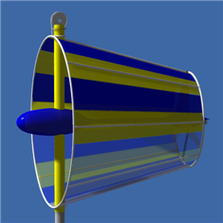 | 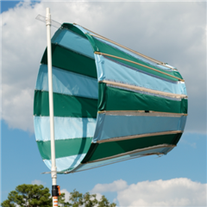
Computer Simulation | Prototype vTurbine™ Sail

2. PROBLEM DESCRIPTION

Conventional wind turbines depend on the strength and vagaries of the ambient wind for their performance. The power generated by a wind turbine grows as the cube of windspeed according to:
Where is a pressure coefficient, A is the swept cross-sectional area, is air density and v is velocity.
Wind turbines situated in low wind areas tend to perform poorly because of this. Consider for example the popular Bergey XL-1 wind turbine:

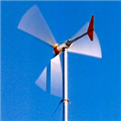
Bergey XL-1

With a blade diameter of 8.2 feet its generator produces 1000 watts at a wind speed of 24.6 mph. That same unit, when operated in the central Arkansas 7.8 mph average winds produces a mere 29 watts:

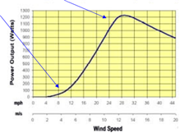
Bergey XL-1 Power vs. Wind Speed

Thus performance suffers by a factor of thirty in typical wind speeds and the equipment fails to meet expectations or achieve payback in a timely manner. This leads to an analytic figure of merit that the vTurbine™ achieves, an improvement of 31 fold - See spreadsheet below.

3. A BETTER SOLUTION

The Venturi Effect is well-known in engineering practice. From continuity a nozzle of varying cross-sectional area has as its governing equation:

For applications that are significantly subsonic such as ours and we have:

Solving this equation for yields:

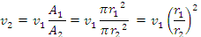

Applying this to our low-wind predicament we see that an increase in cross-sectional area produces a velocity increase proportional to the square of the ratio of the radii.

The next page shows some preliminary figures obtained for a practical vTurbine™ prototype.

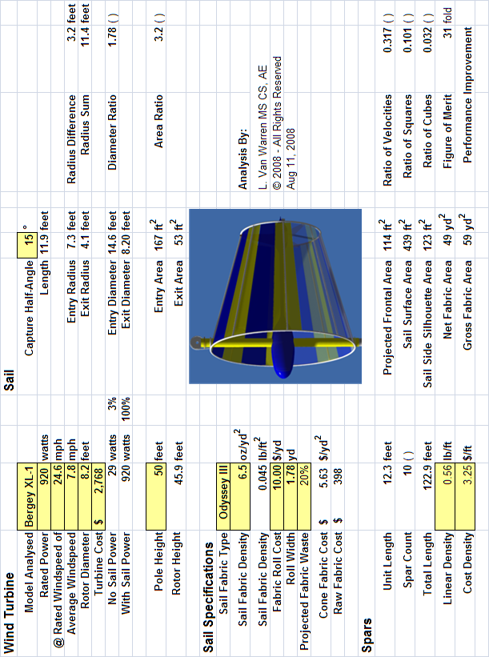

As the calculations above demonstrate a conical sail 14.6 feet in diameter increases an average wind of 7.8 mph to an average exit velocity of 24.6 mph and restores the turbine to its rated performance in low wind conditions.

In a limiting argument one might ask, why not just lengthen the blades of a wind turbine by the same amount as the sail entry radius?

The conical sail has the advantage of subtending the entire capture area simultaneously. A turbine blade, on the other hand, can only occupy a fraction of the available surface area due to its finite width. The sail magnifies velocity passively by focusing the winds of a large cross-section into a smaller one. Because fabric structures, especially tensile ones are relatively low in cost, they are a better solution – a better solution than subjecting a larger turbine to the same low winds. This makes for a more effective match of the driving force to the generator load.

Adding a sail is the most visible innovation, but not the most critical. We have also created an auto-reefing system, that protects the vTurbine™ installation in high wind and weather advisory situations. A microcontroller continuously monitors the wind speed and automatically places the system in a safe configuration whenever necessary. This same monitoring allows performance to be optimized for a variety of ambient conditions.

4. MEASUREMENT AND REAL-TIME DIGITAL CONTROLS

Besides a comprehensive performance measurement campaign that will include digital anemometers and data acquisition, we are fielding additional innovations that exploit the revolution in digital control. Real-time digital monitoring and control enable us to adaptively adjust key sail parameters that minimize loads on the tower. These innovations not only increase the patentability of the device, but aid in servicing and maintaining the unit conveniently and at low-cost. This concludes the technical summary of the invention.

5. PRIOR ART AND PREVIOUS RESEARCH

Four simultaneous circumstances have conspired to create a “perfect storm” for moderate-scale wind energy development and thus for the appearance of the vTurbine™. These are:

The availability of cost-effective composite materials such as carbon fiber.
The availability of low-cost digital microcontrollers for monitoring.
The manufacturing of high-performance wind turbines.
A global increase in demand for wind energy at farm, residential, neighborhood scales.

6. PROTYPING PROGRAM – WORK TO DATE

From the outset, an ambitious computer simulation effort was mounted to assess the cost-benefit and predict the optimal sizing of the sail with respect to specific off-the-shelf wind turbine technology.

7. OVERCOMING BARRIERS TO PRODUCTION

Van will fill this in.

8. COMMERCIALIZATION, MANUFACTURING AND PROCESS

9. MARKET NICHE

1. Specific customer needs the product satisfies:

The vTurbine fills the niche for a device which augments the effect of low wind conditions when wind energy is desired as part of the mix of energy sources for a business, farm, or residence. Customers need effectiveness,
reliability, reasonable pricing, servicing convenience and low cost of maintenance, eye appeal, a way to protect the device from winds too strong, and
to do this, VentureWind will assemble and install the whole system, connect it to the electric grid, and warranty it for parts and labor.

2. Will the market support the product?

Yes, we think so, since we are the only product which purports to have so many advantages in low wind conditions.

Wind energy is one of the two fastest-growing sources of energy in the energy market today. Along with solar energy, wind systems are in increasing demand worldwide, especially in places such as Denmark, Germany, Spain, and enlightened states such as California, Kansas, Texas, Oklahoma, Minnesota, Washington, Oregon, etc. Just as residents of Little Rock have learned that LM Glasfiber, a Danish company, is making wind blades for large out of state wind farms, VentureWind will be making a product and a wind system for small wind applications, and the market may be largely an out of state for awhile, until Arkansans become aware what small wind systems will do for their personal and business economy.

Our product, the vTurbine, should cost an additional $1,000-1,200 cost to a wind system. It requires a slightly taller tower (60-70 ‘) than conventional small wind systems (30-50’), to take advantage of the higher wind velocities above the trees. The tower will be a little more expensive, as will the device that raises and lowers the turbine. However, our calculations are that the cost of the refinements we are making will lower the payback period from 10 years (in the current Arkansas incentive climate) to 2-3 years, which lowers total costs.

3. Who is the competition?

4. Does the product, process, or innovation provide a competitive edge?

5. Is there adequate financial support?

6. Does the budget support the implementation plan?

7. Is the commercialization plan valid?

8. Can key personnel support the project?

In the world of wind energy production equipment, there is small, intermediate, and large scale wind equipment, referring to the size of the equipment that would be appropriate for the average wind velocity for a given year in a given location. The small wind distributive energy market is the niche where we will be competing. Small wind refers to wind systems which generate less than 10 kilowatts at a given moment. These are generally low maintenance systems, and they last about 25 years. Small wind turbines are very suitable for becoming part of the energy supply for farms, homes, small to intermediate sized businesses at the edge of towns and cities, and recently, they are being added to the tops of city buildings. Most of the earth has low wind conditions enough of the time that one could say that low wind or small wind is the norm. (See Attachments: U.S. and Arkansas wind map and Wind Powering America, a Department of Energy Fact Sheet.) We believe, also, that our wind system will be an attractive addition to the landscape, and that customers will enjoy the custom design feature that we are including.

The unique features of our wind system include the sail which magnifies the wind speed, the reefing ability (it can be lowered automatically or by customer remote) which both gets it out of dangerously high wind danger and allows its owner to bring it down for easy, safe maintenance, eliminating the need for an expensive crane rental and a dangerous repair experience for a technician.

The wind power industry grew 45% in 2007. New wind power installations constituted 35% of all new electric power installations. Wind power reduces water consumption in the electric power sector of the market, it reduces greenhouse gas, CO₂, and it increases the economic prosperity, especially in rural areas where income is always needed. The U.S. Department of Energy predicts impacts of 1,000 megawatts of wind energy from Arkansas in the future. Six states have already reached the 1000 mw mark. VentureWind, Inc. is towards the crest of this wave with our innovative vTurbine wind system.

Small wind systems can boost local energy supplies and stimulate rural economies. Rural electric cooperatives are starting to add wind to their portfolios. If enough wind and solar were added to energy supplies, new coal plants which emit heavy pollution and global warming could be replaced with clean, completely sustainable energy sources. In the future, clean energy will be more cost-effective than dirty energy, and this will move the cost of wind energy down. Large corporate wind farms may dominate the high dollar side of the market for a couple of decades, we predict; however, the small wind market has a great capacity to fill in the countryside where the large wind farms cannot go. Large wind systems have to go where there is large wind, of which there are few patches in Arkansas. (See Appendix for Arkansas Wind Map).

By the time we go into production, we hope Arkansas and many other states will have enacted a Production Tax Credit or Feed-in Tariff, which encourages consumers to produce their own power and more, to sell to the grid. When this occurs, the vTurbine small wind system will be in greater demand, because then it can actually make an three bedroom two bath home (1100-1300 kWh per month) customer $2-3,000 more per year than the typical electric bill.

The vTurbine system will power a small business, a farm, or a three bedroom two bath home in Arkansas and make enough extra power when mixed with other energy sources so there are no breaks in service, with production incentives, to pay the electric bills and, in addition, have $2-3,000 in their pocket. This cannot be said for the conventional small wind turbine. The payback period for our invention, the vTurbine system, is about three or four times shorter than for a conventional wind system. This is the advantage of the vTurbine wind system over every other product in our niche.

10. IMPLEMENTATION PLAN

Timetable and Schedule

Narrative Description of Fund Use

Support Facilities, Equipment, Tooling, Personnel

11. BUDGET FOR PROJECT PERIOD AND DESIGNATED PHASES

12. QUALIFICATIONS OF PRINCIPLES INCLUDING RESUMES

Chief Technical Officer and Chief Executive Officer: L. Van Warren

The inventor of the vTurbine wind system, Van Warren has two master’s degrees, one in from and one in from
His work experience related to this project includes:

Chief Operations Officer: Dina Nash

Mrs. Nash also has two master’s degrees, one in Administrative Social Work from the University of Arkansas at Little Rock and one in Criminology from Florida State University in Tallahassee. Her work experience related to this project is that she has developed and run a summer day camp business in Fayetteville, Camp Mountain Brook, for three years, and she has run her own counseling business for 27 years. The camp involved program design, contracts, employee hiring, training, and human relations, and all the administrative duties that go with managing hundreds of campers safely. Mrs. Nash has done training and workshops in her 27 year career in counseling, and that business included five years of program planning and development in state agencies. Also, she has taught sociology, social work, and criminology for eight years at the college level and taught four years at the secondary level in Arkansas schools. Her interest in helping the U.S. solve its energy crisis is her motivation to enter the alternative energy field as her third career.

(See Attached Resumes)

13. ECONOMIC IMPACT PROJECTIONS

Will the product impact Arkansas’ economy?

Does it have job creation potential?

Does it add value to existing products?

Can it be exported?

Job Creation

We envision providing the following jobs during year one of production: Chief Technical Officer, Chief of Operations, a half time secretary/bookkeeper, a half time Assembler, and a half time Electrician. In addition, a marketing firm and an attorney’s services will be secured, part-time. During year two, Mrs. Nash will just do administration and a Sales person will be added, and other employees will likely be full-time. During years three and beyond, we project that we will need more Assemblers and more marketing and sales personnel, depending on the level of sales to expand those positions.

Benefits to the community will be the property taxes we pay, the cleanliness of our manufacturing operation and of the energy we generate, and the products which give power to whatever applications our customers want to use them for. Wind power not only meets the needs of the customers for power, but meets the needs of the community as a whole for clean power, air, and water.

The Arkansas Department of Energy reports that there are several drivers of economic benefits to consumers and their communities. These include: the use of local construction companies (which we will do), the presence of in-state component suppliers (some of which we have for our product), favorable local wage and property tax structures (which vary), and low operation and maintenance costs (which we will have).

Export Potential

Value Added to Existing Products

14. INTELLECTUAL PROPERTY (IP) AND PROTECTION - PATENTS

PATENTABILITY

1. Has a patent been applied for?

2. Are there similar patents granted?

3. Can the concept be protected by a patent?

The vTurbine™ has at least three areas of patentability that exceed that of prior art. At the present time complete disclosure of these areas is a trade secret and a non-disclosure agreement is in place with all agencies distributing this document. The filing of provisional patents in these areas is underway. The filing of long-term patents will follow on completion of the full-scale prototype as additional patentable contributions are anticipated.

Patent Area One – Automatic Reefing

The benefits of automatic reefing are:

Protecting the vTurbine™ and the vTower™ from damage in high winds.
Protecting the vTower™ from damage in high winds.
Enabling easy inspection and maintenance of the unit.

A significant problem with existing wind turbines is that they create a visual intrusion. People tend to forgive a visual intrusion if it is producing useful power, but they become irritable if a turbine is non-functioning. This upshot of this is that non-functioning wind turbines are viewed as an eyesore and need to be taken down for service and repair. Unfortunately for conventional wind turbines, this is a costly activity. Obtaining a crane, a crew and tower climbers represents a significant portion of the expense of erecting the unit in the first place. So the tendency is that non-functional units remain in place, generating complaints and discouragement about wind power. Our prototyping work has shown the vTurbine™ sail is actually an attractive and enchanting indicator of wind conditions. It creates its own aesthetic and environmentally harmonious advertising. Thus we expect it to sell itself.

The vTurbine™ completely circumvents this by a raising and lowering the unit under real-time control. This was originally done to optimize performance in varying wind conditions. However it turns out that raising and lowering the unit greatly enhances the convenience of servicing and lowers maintenance costs by at least an order of magnitude. No crane, crew or tower climbers are required for routine maintenance.

In normal operation, a computerized monitoring and control unit adjusts the height of the vTurbine™. In high winds, the unit is brought down to ground level by computer or direct command. In hurricane or extreme conditions the vTurbine™ can be lowered, the blade locked, the sail reefed, and the frame tethered to a bollard in a short period of time – on the order of minutes.

Not only can the mechanical portions of this automatic reefing system be patented, the software algorithms can be patented, copyrighted, and when necessary held as trade secrets. Thus this will be an area of multiple instances and types of IP protection.

Patent Area Two – Venturi Plus High Performance Turbine
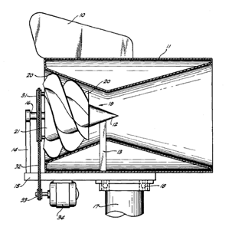
Carpenter’s Patent #421875

In US patent #4218175 which has since expired, Robert D. Carpenter combined a Laval Nozzle with a cumbersome and aerodynamically inefficient helical turbine. The Laval Nozzle included both a converging and diverging section, as well as an external and internal wall. Consequently the unit was cumbersome, heavy and difficult to field. Compounding this, the unit was inefficient primarily due to rather arcane turbine technology that was incorporated. The vTurbine™ corrects these deficiencies by combining state-of-the art turbine blade technology with a truncated conical single-walled sail. This combination is lighter, smaller and superior than the technology of #4218175. Enhancing our current position are the availability of composite materials and better understanding of turbine blade technology. This patent would be cited as prior art, but the truncation of the Laval Nozzle into a conical sail is both a significant and non-obvious improvement to the design.

Patent Area Three – Stability and Control

Preliminary versions of the vTurbine™ showed that sail stability and control are important attributes of a fully featured unit. Naïve implementations of our concept will have oscillation problems that we have already encountered and solved in an ambitious prototyping campaign. This gives us an advantage in time-to-market.

15. INTELLECTUAL PROPERTY (IP) - TRADEMARKS

Trademarks whose registration is pending include

vTurbine™

vTower™

ventureWind™

16. INTELLECTUAL PROPERTY (IP) – COPYRIGHTS AND TRADE SECRETS

Software implemented for the purpose of monitoring the system is copyrighted by default under the Digital Millennium Copyright Act (DMCA). In addition disclosure of the source code of the software will be tightly controlled. Because of the compilation and loading of the software into the microcontrollers, it will be extremely difficult to reverse engineer the compiled machine code into anything recognizable or useful.

Financial support

Attached Documents – List

Phase 1 and Phase 2 Financial Spreadsheets

Design and Analysis Spreadsheets

Photographs and Test Results

Arkansas Wind Map, National Renewable Energy Laboratory,
50 meters above ground, 2006 (PowerMap)

Wind Powering America: Program Overview. Fact Sheet, 2008.
Department of Energy, National Renewable Energy Laboratory.

Van Warren and Dina Nash’s Resumes

