The vTurbine™ -

An Enhanced Wind Turbine for Low Wind Areas

Van Warren

August 10, 2008

Contents

* Introduction
* Problem Description
* A Working Solution
* Additional Innovation
* Request for Letter of Evaluation
* Suggested Letter Format

Introduction

As briefed in our conversation, I am working on the design of a wind turbine whose design is enhanced by the use of a tensile structure. In this case the tensile structure – is a venturi-shaped sail, the frustum of a cone. The entire assembly is called the vTurbine™, and the sail part is, well, just the sail.

|  |  |
| --- | --- |
|  |  |
| Computer Simulation | Prototype vTurbine™ Sail |

Problem Description

Conventional wind turbines depend on the strength and vagaries of the ambient wind for their performance. The power generated by a wind turbine grows as the cube of windspeed according to:

$$Power=Force ∙velocity=C_{d}A\left[\frac{1}{2}ρv^{2}\right]v={\frac{1}{2}C}_{p}Aρv^{3}$$

Where $C_{p}$ is a pressure coefficient, A is the swept cross-sectional area, $ρ$ is air density and v is velocity.

Wind turbines situated in low wind areas tend to perform poorly because of this.

Consider for example the popular Bergey XL-1 wind turbine.

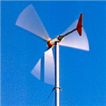

Bergey XL-1

With a blade diameter of eight feet its generator produces 1000 watts at a windspeed of 24.6 mph. That same unit, when operated in the central Arkansas area produces a mere 37 watts when operated in the 7.6 mph average winds:

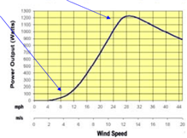

Bergey XL-1 Power vs. Wind Speed

Thus performance suffers by a factor of thirty in wind speeds that are one-third of the optimal value and the equipment fails to meet expectations or achieve payback in a timely manner.

A Working Solution

The Venturi Effect is well-known in engineering practice. From continuity a nozzle of varying cross-sectional area has as its governing equation:

$$ρ_{1}v_{1}A_{1}{=ρ}_{2}v_{2}A_{2 }$$

For applications that are significantly subsonic such as ours $ρ_{1}{=ρ}_{2}$ and we have:

$$v_{1}A_{1}=v_{2}A_{2 }$$

Solving this equation for $v_{2}$ yields:

$$v_{2}=v_{1}\frac{A_{1 }}{A_{2 }}=v_{1}\frac{{π{r_{1}}^{2}}_{ }}{π{r_{2}}^{2}} =v_{1}{\left(\frac{r_{1}}{r_{2}}\right)}^{2}$$

Applying this to our low-wind predicament we see that an increase in cross sectional area produces a velocity increase proportional to the square of the ratio of the radii.

The next page shows some preliminary figures obtained for a practical vTurbine™ prototype.

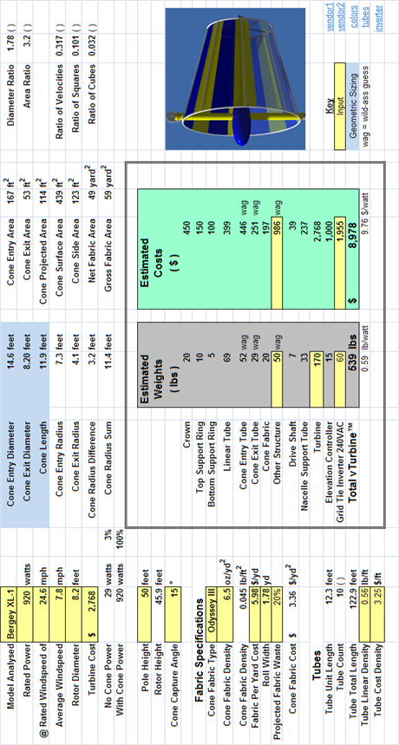

As the calculations above demonstrate a conical sail 14.6 feet in diameter increases an average wind of 7.6 mph to an average exit velocity of 24.6 mph and restores the turbine to its rated performance in low average wind conditions. The resulting increase in dynamic pressure is accompanied by a decrease in static pressure, but since the static pressure is normal to the flow direction, this does not perturb the performance of the turbine.

In a limiting argument one might ask, why not just lengthen the blades of a wind turbine by the same amount as the sail entry radius?

The conical sail has the advantage of subtending the entire capture area, simultaneously while a blade can only occupy a fraction of the available surface area due to its finite width. The sail magnifies velocity passively by focusing the winds of a large cross-section into a smaller one. Because fabric structures, especially tensile ones are relatively low cost, t hey are a better solution – a better solution than subjecting a larger turbine to the same low winds. This makes for a more effective match of the driving force to the impedance of the load.

Additional Innovations

Besides a comprehensive performance measurement campaign that will include digital anemometers and data acquisition we are fielding additional innovations that exploit the revolution in digital control. Real-time digital measurement and control enable us to adaptively adjust key sail parameters that minimize peak bending moments at the base of the supporting tower. Due to ongoing patent considerations I must curtail detailed discussion of these for now, but I will be happy to provide them over the phone if you are interested. I will say that these innovations not only increase the patentability of the device, but aid in servicing and maintaining the unit conveniently and at low-cost.

This concludes the technical summary of the invention for now.

The following page details a request for a letter of evaluation.

Request for a Letter of Evaluation

J. Steve Stanley and his committee at the Arkansas Science and Technology Authority is considering a request for funding for construction of a full scale prototype of the vTurbine™ described herein.

Dr. Stanley has requested that I obtain an evaluation of this concept from a qualified engineer and you are the most qualified tensile structure engineer I know of anywhere.

Their concern is filtering out flim-flam, perpetual motion and various quack schemes that have no technical viability.

This document along with supporting information I have provided you on the phone will hopefully assist you in your evaluation, and I am available 24/7 to respond to any follow-on questions you may have via my email: [van@wdv.com](mailto:van@wdv.com)

Suggested Letter Format

Pending your qualified review, a sample letter on your professional letterhead might take the following form:

*J. Steve Stanley*

*Vice-President Commercialization*

*Arkansas Science & Technology Authority*

*423 Main Street, Suite 200*

*Little Rock, Arkansas 72201*

Dear Dr. Stanley

*I have reviewed the concept of the vTurbine™ - a wind turbine enhanced by the addition of a Venturi-effect sail and various digital controls. The concept on its face appears technically viable and worth pursuing, at least to the point of constructing a full scale prototype. My experience with L. Van Warren MS CS, AE, leads me to believe he is a suitably trained engineer to pursue this concept wherever it may lead. Thank you.*

*Salutation and Professional Qualifications Summary*