vTurbine™ Provisional Patent Information

L. Van Warren, Inventor
501-664-4011 (w)
231-5426 (c)
van@wdv.com

The inventor affirms the information contained herein to be accurate and truthful to the best of his ability.


L. Van Warren
Aug 11, 2007

CONTENTS

1 DESCRIPTION OF vTURBINE™ 4
2 PROBLEM DESCRIPTION 4
3 A BETTER SOLUTION 5
4 MEASUREMENT AND REAL-TIME DIGITAL CONTROLS 7
5 PRIOR ART AND PREVIOUS RESEARCH 7
6 PROTYPING PROGRAM – WORK TO DATE 7
7 OVERCOMING BARRIERS TO PRODUCTION 10
8 COMMERCIALIZATION, MANUFACTURING AND PROCESS 10
8.1 Commercialization of the vTurbine Wind System: 10
8.1.1 WHAT we are selling: 10
8.1.2 WHO our customers are: 10
8.1.3 HOW we manufacture and market our product: 10
8.1.4 WHEN our Phase 1 and Phase 2 objectives are accomplished: 11
8.2 Manufacturing and Process: 11
9 MARKET NICHE 12
9.1 Description of Our Niche in the Wind Industry: 12
10 IMPLEMENTATION PLAN 13
10.1 Timetable and Schedule 13
10.2 Narrative Description of Fund Use 13
10.3 Support Facilities, Equipment, Tooling, Personnel 14
11 QUALIFICATIONS OF INVENTOR INCLUDING RESUMES 14
11.1 L. Van Warren 14
12 INTELLECTUAL PROPERTY (IP) - PATENTS 16
12.1 Patent Area One – Automatic Reefing 16
12.2 Patent Area Two – Venturi Plus High Performance Turbine 17
12.3 Patent Area Three – Stability and Control 18
13 IP - TRADEMARKS 19
13.1 vTurbine™ 19
13.2 vSail™ 19
13.3 vTower™ 19
14 IP– COPYRIGHTS AND TRADE SECRETS 19

Table of Figures
vTurbine™ Computer Model 4
Prototype vTurbine™ Sail 4
Bergey XL-1 4
Bergey XL-1 Power vs. Wind Speed 5
vTurbine™ Preliminary Calculations 6
Frame and Sail Fabrication 8
Frame and Sail Integration 8
Pole Mount for Early Truck Tests 8
Improved Sail Under Static Test 8
Improved Sail in High Speed Test 8
vTurbine™ Prototype Internals Sketch 9
Budget for Project Period – Phases 1 & 2 15
vTurbine™ Full Scale Prototype Costs 16
vTurbine™ Installation Costs 17
vTurbine™ Projected Sales 18
Carpenter’s Patent #421875 24

DESCRIPTION OF vTURBINE™

As briefed in our previous presentation, the product is a wind turbine whose design is enhanced by the use of a tensile structure. In this case the tensile structure is a venturi-shaped sail, the truncated frustum of a cone. The entire assembly including the generator is called the vTurbine™, and the sail part is, well, just the sail.

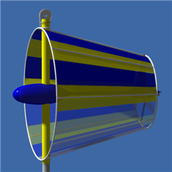 | 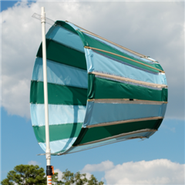
vTurbine™ Computer Model | Prototype vTurbine™ Sail

PROBLEM DESCRIPTION

Conventional wind turbines depend on the strength and vagaries of the ambient wind for their performance. The power generated by a wind turbine grows as the cube of windspeed according to:
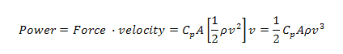
Where is a pressure coefficient, A is the swept cross-sectional area, is air density and v is velocity. This is known as the cube law of power for wind turbines. Wind turbines situated in low wind areas tend to perform poorly because of this cubic dependence on ambient wind speed. Consider for example the popular Bergey XL-1 wind turbine:
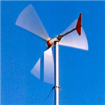
Bergey XL-1
With a blade diameter of 8.2 feet its generator is rated to produce as much as 1000 watts at a wind speed of 24.6 mph. That same unit, when operated in the central Arkansas 7.8 mph average winds produces a mere 29 watts. The arrows show the actual versus rated performance.

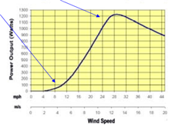
Bergey XL-1 Power vs. Wind Speed

Performance suffers by a factor of thirty at typical wind speeds and the equipment fails to meet expectations or achieve payback in a timely manner. Adding a sail and digital controllers creates the vTurbine™ which achieves a performance improvement of 31 fold - See spreadsheet below.

A BETTER SOLUTION

The Venturi Effect is well-known in engineering practice. From continuity a nozzle of varying cross-sectional area has as its governing equation:
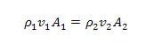
For applications that are significantly subsonic such as ours and we have:
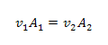
Solving this equation for yields:
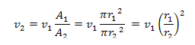
Applying this to our low-wind predicament we see that an increase in cross-sectional area produces a velocity increase proportional to the square of the ratio of the radii. The next page shows some preliminary figures obtained for a practical vTurbine™ prototype.

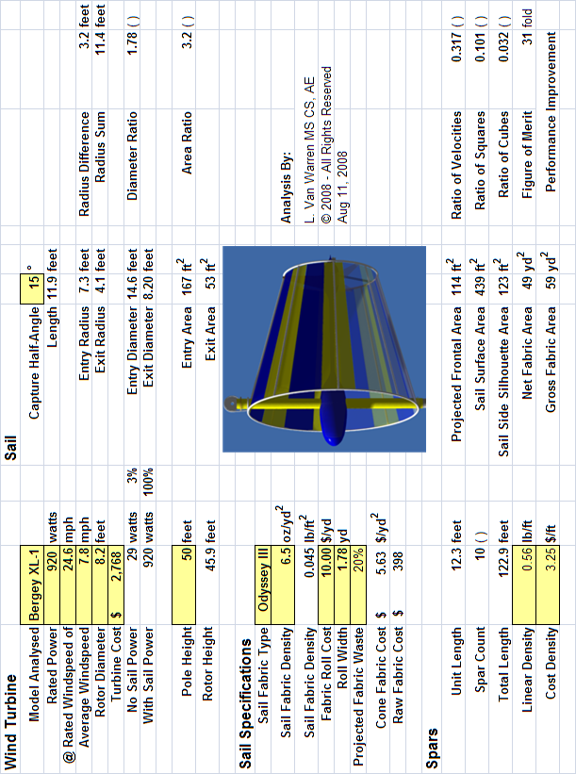

vTurbine™ Preliminary Calculations
As the calculations above demonstrate a conical sail 14.6 feet in diameter increases an average wind of 7.8 mph to an average exit velocity of 24.6 mph and restores the turbine to its rated performance in low wind conditions.

In a limiting argument one might ask, why not just lengthen the blades of a wind turbine by the same amount as the sail entry radius?

The conical sail has the advantage of occupying the entire capture area simultaneously. A turbine blade, on the other hand, can only occupy a fraction of the available surface area due to its finite width. The sail magnifies velocity passively by focusing the winds of a large cross-section into a smaller one. Because fabric structures, especially tensile ones are relatively low in cost, they are a better solution – a better solution than subjecting a larger turbine to the same low winds. This makes for a more effective match of the driving force to the generator load.

Adding a sail is the most visible innovation, but not the most critical.

We have also created an auto-reefing system, that protects the vTurbine™ installation in high wind and weather advisory situations. A microcontroller continuously monitors the wind speed and automatically places the system in a safe configuration whenever necessary. This same monitoring allows performance to be optimized for a variety of ambient conditions.

MEASUREMENT AND REAL-TIME DIGITAL CONTROLS

Besides a comprehensive performance measurement campaign that will include digital anemometers and data acquisition, we are fielding additional innovations that exploit the revolution in digital control. Real-time digital monitoring and control enable us to adaptively adjust key sail parameters that minimize loads on the tower. These innovations not only increase the patentability of the device, but aid in servicing and maintaining the unit conveniently and at low-cost.

PRIOR ART AND PREVIOUS RESEARCH

Four simultaneous circumstances have conspired to create a “perfect storm” for moderate-scale wind energy development and thus for the appearance of the vTurbine™. These are:

- The availability of cost-effective high performance composite materials.
- The availability of low-cost digital microcontrollers for monitoring.
- The manufacturing of high-performance wind turbines.
- A global increase in demand for wind energy at farm, residential, neighborhood scales.

PROTYPING PROGRAM – WORK TO DATE

From the outset, an ambitious computer simulation effort was mounted to assess cost versus benefit and predict the optimal sizing of the sail with respect to specific off-the-shelf wind turbine technology. This document opens with a computer model of the vTurbine™ and this has been followed up by the construction of a 1/5 scale model of the vTurbine™ sail. Some pictures and sketches of the prototyping activity follow:

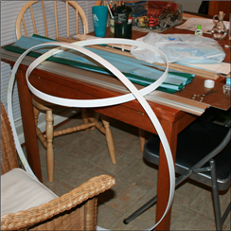  Frame and Sail Fabrication | 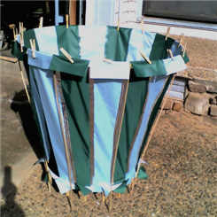  Frame and Sail Integration
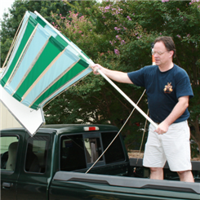  Pole Mount for Early Truck Tests | 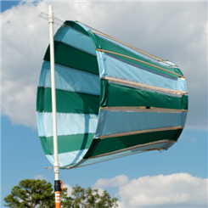  Improved Sail Under Static Test
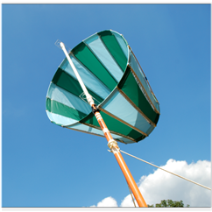  Improved Sail in High Speed Test | 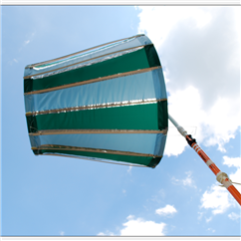  Improved Sail in Extended Test

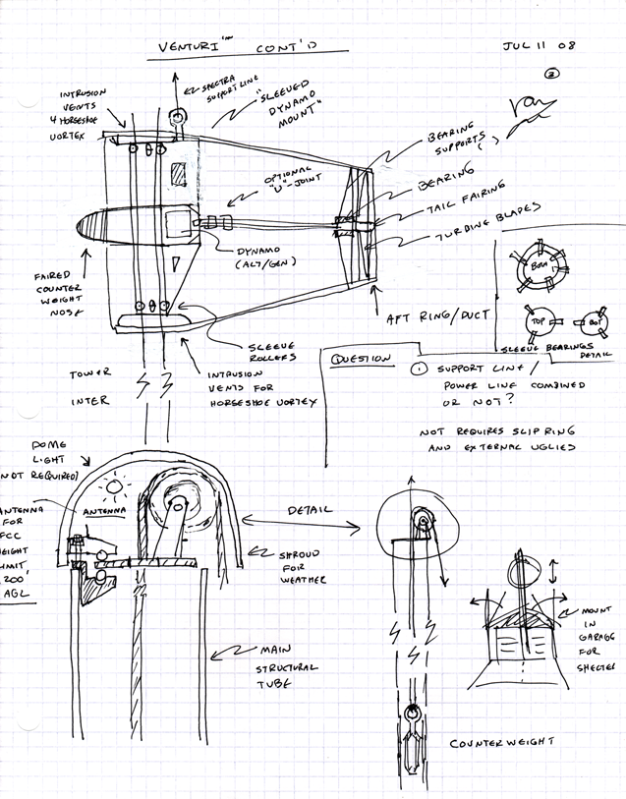
vTurbine™ Prototype Internals Sketch

OVERCOMING BARRIERS TO PRODUCTION

Production is slated for Arkansas, with an Arkansas labor force. Due to the availability of cost effective manufacturing space and manpower in Arkansas, we foresee no unusual barriers to production. Suitable weather resistant fabric materials for the sail are widely available from multiple vendors to the sailing, parachuting, tent and awning industries. Careful attention is being paid to creating conveniently-sized and easily-shipped components that can be assembled on-site with a minimum of tools.

COMMERCIALIZATION, MANUFACTURING AND PROCESS

Commercialization of the vTurbine Wind System:

Going from prototype to market involves being clear what we are selling, to whom, how, when, and where we do so.

WHAT we are selling:
Our product that embodies two concepts:

- Thirty-fold performance improvement. This changes a product with low return on investment to a higher state which produces a higher rate of return on investment in a shorter payback period.
- Reliability and Safety: Our product is easy to use and safe to maintain. After installation there is no need for cranes, trained climbers, or risk with electrical metering devices at the utility pole.

WHO our customers are:
We have at least three kinds of customers:
- Individuals who want them for their distributive power needs on farms and in residential situations which permit them;
- Businesses which need them for their distributive power needs (Wal-Mart is planning several wind turbines in store parking lots); and
- Community groups such as neighborhoods, churches, industrial parks, small towns, etc. The national wind associations have many examples of cooperative wind projects which are working well. See Wind Associations Attachment.

HOW we manufacture and market our product:

The vTurbines™ are unique in that they constitute their own aesthetic and harmonious signage and advertising. This will allow word-of-mouth, the most powerful kind of marketing to be a principle asset. We will exploit existing marketing surveys through them and carefully target our sales efforts towards the most likely markets first. Obviously, such marketing has to be towards targets who have the money to buy these devices and who need them now and who can afford the transportation and installation costs, as well as the price of the device. Because of our vTurbine and the other features of our wind system, we will not be the cheapest product, but the most efficient and safe. When people see what it can do, they will be willing to buy the best system in the small wind market. We know that our marketing venues will include wind trade shows and wind publications, technology conferences, newspaper and internet advertising, and demonstration turbines, such as our prototype which we hope to have your help to develop.

WHEN our Phase 1 and Phase 2 objectives are accomplished:

When we have made our full scale model and have tested it fully and when have secured funding to spend on marketing, we will engage the services of a marketing firm to develop a plan for commercialization of our wind system. We anticipate this date’s being in February 2009, if initial funding is granted through A.S.T.A.

- First Priority: VentureWind will market to customers whose states have wind production tax and other incentives, since these are people and businesses which will have more available cash to spend on such devices, due to faster payback on investment dollars. We know what those 25 states are.

- Second Priority: we will market to customers who do not have tax incentives, because we know many of those individuals will want to supplement their energy source, no matter what the cost up front, because of long term savings and environmental ethics (wanting to participate in the conservation of natural resources and global warming reduction and to at least do net metering).

Manufacturing and Process:

VentureWind is planning to have the sail portion of our wind system manufactured by contract with sail and parachute manufacturers, and we are doing further research to determine our best source or sources. We have identified all the materials and costs for the sails and for all the parts in the rest of the wind system. We are planning to have the generator built by the maker of the most efficient generator we can buy in the U.S. at the time (at present that is the Bergey Company’s brand). We are planning to buy the tower from a source which manufactures cell phone towers, since we need taller towers than some small wind systems use. We are planning to buy materials to rig the special reefing characteristics of our product and buy the net metering equipment with which to assemble the whole system.

Our manufacturing/assembly plant in the Central Arkansas area will be clean industrial worksite with large tables and hand tools for system integration and rigging (cables, counterweights, etc.) and any modifications we have to do to the generators. We will not have to store large quantities of bulky items, since the towers will be shipped directly to the customer’s site for assembly there, and we will order generators as we need them. Assembly of all the parts will be done at the customer’s site, and we will transport by UPS all components, except the towers for on-site assembly.
We will hire Assemblers which we will train, and Electricians to connect the net metering equipment to our assembled system, as we need them by contract, at first, then more and more full time ones as our orders increase.

Connecting the vTurbine system into the grid will be the responsibility of the customer and the utility company, cooperating. Our work will be done when we test the final assembly and the installation job.

MARKET NICHE

Description of Our Niche in the Wind Industry:

In the world of wind energy production equipment, there is small, intermediate, and large scale wind equipment, referring to the size of the equipment that would be appropriate for the average wind velocity for a given year in a given location. The small wind distributive energy market is the niche in which we will be competing. Our initial offerings will be systems that generated 10 kilowatts or less. Wind turbines of this size are very suitable for becoming part of the energy supply for farms, residences where local ordinances permit them, which in Arkansas is liberally regulated at the moment, small to intermediate sized businesses at the edge of towns and cities, and recently, they are being added to the tops of city buildings. See Arkansas Wind Map Attachment and Department of Energy Fact Sheet. Our wind systems will be an attractive addition to the landscape due to the flexible coloration of the sail.

The unique features of our wind system include the sail which magnifies the wind speed, the reefing ability (it can be lowered automatically or by customer remote) which both gets it out of dangerously high wind danger and allows its owner to bring it down for easy, safe maintenance, eliminating the need for an expensive crane rental and a dangerous repair experience for a technician.

The U.S. Department of Energy project that wind can become 20% of our energy portfolio. The wind power industry grew 45% in 2007. New wind power installations constituted 35% of all new electric power installations. Wind power reduces water consumption in the electric power sector of the market, it reduces greenhouse gas, CO₂, and it increases the economic prosperity, especially in rural areas where income is always needed. The U.S. Department of Energy predicts impacts of 1,000 megawatts of wind energy from Arkansas in the future. Six states have already reached the 1000 mw mark. VentureWind, Inc. is towards the crest of this wave with our innovative vTurbine wind system.

Small wind systems can boost local energy supplies and stimulate rural economies. Wind power is an investment in rural America, and one can use Sweetwater, Texas, as an example. It was a dying town of 10,000 when a large wind facility was built outside town. So it experienced a revival, and the population has grown back up to 12,000. Rural electric cooperatives are starting to add wind to their portfolios. If enough wind and solar were added to energy supplies, new coal plants which emit heavy pollution and global warming could be replaced with clean, completely sustainable energy sources. In the future, clean energy will be more cost-effective than dirty energy, and this will move the cost of wind energy down. Large corporate wind farms may dominate the high dollar side of the market for a couple of decades, we predict; however, the small wind market has a great capacity to fill in the countryside where the large wind farms cannot go. Large wind systems have to go where there is large wind, of which there are few patches in Arkansas. See Arkansas Wind Map Attachment.

By the time we go into production, we expect Arkansas and many other states will have enacted a Production Tax Credit or Feed-in Tariff of 5-7 cents per kilowatt, which encourages consumers to produce their own power and sell their surplus energy to the grid. When this occurs, the vTurbine small wind system will be in greater demand, because then it can actually make an three bedroom two bath home (1100-1300 kWh per month) customer $2-3,000 more per year than the typical electric bill. However our product remains viable even without a Feed-in Tariff, especially in states with net-metering laws.

The vTurbine™ system will power a small business, a farm, or a three-bedroom home in Arkansas and make enough extra power when mixed with other energy sources so there are no breaks in service, with production incentives, to pay the electric bills and, in addition, have $2-3,000 in their pocket. This cannot be said for the conventional small wind turbine. The payback period for our invention, the vTurbine™, is about three times shorter than for a conventional wind system. This is the advantage of the vTurbine™ wind system over every other product in our niche.

IMPLEMENTATION PLAN

Timetable and Schedule

The time table extends from the time of grant approval to February 2009. During this period tasks marked “Custom Fab” in the Full Scale Prototype spreadsheet below will be contracted out. Tasks marked “Off the Shelf” will procured and assembled internally. Our objective for the prototype is to serve primarily as system integrators, coordinating major assembly for the Full Scale Prototype. The schedule task list is included in the budget spreadsheets below.

Narrative Description of Fund Use

On receipt of grant funding, the acquisition of dual anemometers for high precision measurements on both the Fifth Scale Model and the Full Scale Prototype will be initiated. Provisional patents in three areas will be filed as mentioned below in the IP section. The anemometers will connect via RS-232 to laptop computers already used by the project to log freestream and accelerated wind speeds in real time. These will be used to fine tune performance of the system and drive the automatic reefing system. On completion of this measurement and tuning activity, the instrumentation will be transferred to work in progress on the full scale model. In parallel with this a monopole tower will be acquired at a cost of $11K and subcontracting of sail construction will commence. Composite components for the frame will be acquired as off-the-shelf stock, and will be assembled on site. An off-the-shelf wind turbine will be secured and modified for drive train changes required by the vTurbine™ configuration. This drive train will be installed in the frame and attached to the monopole tower. After successful demonstration of the reefing system (already in development), the system will be raised on the pole and monitored without the sail. Stresses on the tower will be assessed and system performance will be evaluated. After completion of these preliminary tests, the sail will be integrated and Full Scale Prototyping will commence. At this point demonstrations will be made to the granting agencies.

Support Facilities, Equipment, Tooling, Personnel

Support facilities have already been obtained at relatively low cost by parties wanting to facilitate the project. A modest rental fee of $300 for the use of this space has been included in the budget. The fully equipped workshop consists of 400 square feet that has been used previously by the applicants. Special tooling needs will be contracted out, rented or in specific cases procured to accomplish component integration. Two experienced full-time workers and two part-time workers will assist in integration and assembly tasks.

QUALIFICATIONS OF INVENTOR INCLUDING RESUMES

L. Van Warren

Van Warren's professional training began in at the University of Illinois where he earned a BS in Aerospace Engineering while working as a medical lab technician. After this he worked for the University of Illinois and CERL in Champaign Urbana in the same building where the world's first supercomputer Illiac was designed and built. In his senior undergraduate year he was asked to create a physically accurate model of spacecraft reentry. The simulation that resulted brought honorable mention to his aerospace team in the national Bendix design competition. A later version was used in the preliminary component sizing for the Mars Pathfinder mission that succeeded in landing on, and exploring, the Red Planet. During this time Mr. Warren performed detail wind tunnel analysis and published a report comparing several configurations for vertical wind tunnels for freefall simulation. These wind tunnels are in widespread use today.

After his undergraduate work, Mr. Warren designed the first major geographic information systems that grew to widespread use – CERL’s GRASS GIS. It is still in distribution today. During this period he studied tensile structures with Prof. Edward Kuznetsov, the noted engineer and mathematician. An enthusiastic student of numerical analysis Mr. Warren developed visualization techniques for understanding large linear systems of equations and created visual simulations for Alan George's "Nested Dissection of a Regular Finite Element Mesh".
He then went on to receive his first master's degree in Aerospace Engineering. For this he developed a special purpose language for describing and analyzing the vibrational modes of complex structures. Mr. Warren developed and applied ontological model techniques to common finite element problems. He created one of the first 'C' programming projects that captured the notion of object oriented methodology and complex systems. That thesis is posted on his web site in its entirety.
After a chance meeting with the mathematician Elaine Cohen at SIGGRAPH, he traveled to the University of Utah Graphics Lab. His resulting second thesis in computer science defined a new space decomposition technique - "Geometric Hashing" - which enabled the application of ray tracing algorithm to scenes containing thousands of objects.
While in Salt Lake City he performed produced a computer animation entitled, "Sound Into Graphics". This animation of sound driven computer graphics was done in collaboration with Pat Kane and James Bozek of the University of Illinois.
Graduating from the University of Utah he went to the Jet Propulsion Laboratory in Pasadena, California. During this time he worked on the Time Warp Project and became the manager of the visualization component for a Strategic Defense Initiative project entitled Simulation87.
Reacting to the consequences of possible nuclear conflict, Mr. Warren embarked on a personal investigation on views of the earth as seen from space with Santa Monica muralist and friend of Richard Feynman, Tom Van Sant. Their goal was to depict an earth as seen from space without political boundaries. In the course of his work, sponsored by NASA, The National Geographic Society, and the GeoSphere Project, he was the technical director for the largest mosaic of the earth ever created at that time. Mr. Warren had the privilege of briefing aerospace innovators Paul MacReady, Peter Lissaman, Al Hibbs, Phillip and Phyllis Morrison and many others on this work. The final product entitled, "The Earth from Space", was published in the Boston Globe on Earth Day, the National Geographic Sixth Atlas of the World, and numerous film and television venues to this day.
After this Mr. Warren returned to his aerospace roots and became the cognizant engineer for the Mars Pathfinder Entry Descent and Landing System. His detailed simulations led to the understanding of the reentry system that is still used today. He invented the "drape abatement bridle" that creates a two pendulum system and protects the lander from being draped by the parachute after landing. This work was applied to the first successful Mars Pathfinder Exploration Mission and is still in use in the Spirit and Opportunity missions to Mars.
After Pathfinder Mr. Warren started his own design firm Warren Design Vision and began working on electric cars to reduce pollution and dependence on foreign oil. He designed a hybrid conversion kit for the General Motors Geo Storm. The public was not yet ready for a car that in his words, "traveled half the distance for twice the cost". He then turned to the creation of simulation software products and built high technology web sites for commercial, academic and medical clients.
After this Mr. Warren conceived of the CellWorld™ project to illustrate and animate cellular biology and the results of the human genome project. This represented a return to his original interest in medical technology which paid for his education. His first bioinformatic work was a mathematical study of the number of times that idiomatic expressions recur in gene sequences. He then went on to develop an interactive web-based pharmacology system for cancer pain and a bioinformatic system for exploring genes implicated breast cancer. During this time he developed a comprehensive theory of knowledge mapping for cell simulation.
After trips to Argonne National Labs, Virginia Bioinformatics, and SIGGRAPH, Mr. Warren contributed his talents towards the design of the Virtual Reality Center at the University of Arkansas. This Center featured a merged capability of the Access Grid Internet II, a Silicon Graphics Reality Center and clustered 32-node PC based supercomputer.
To extend his experience in modern networking technology, Mr. Warren then became the founding member of the element management system for Alltel. During this time he successfully participated in the cutover of Verizon telecommunication properties valued at $1.4 billion. The cutover was successful and saved Alltel $200 million dollars. After helping to build the EMS group and create graphical displays he received intensive Sun training in Java. Wanting to focus on new software projects, he left Alltel and developed new software. His most recent tool KnowledgeGazer™ shows promise as a data mining tool for illustrating biological pathways and discovering new links in previously published information.

The advent of the most recent energy crisis has motive him to examine the wind turbine problem in more detail. It was in the process of trying to fix the demonstration wind turbine planned for Dunbar Gardens that the vTurbine™ was conceived and invented.

INTELLECTUAL PROPERTY (IP) - PATENTS

The vTurbine™ has at least three areas of patentability that exceed that of prior art. At the present time complete disclosure of these areas is a trade secret and a non-disclosure agreement is in place with all agencies distributing this document. The filing of provisional patents in these areas is underway. The filing of long-term patents will follow on completion of the full-scale prototype as additional patentable contributions are anticipated.

Patent Area One – Automatic Reefing

Reefing is defined as the process of reducing sail area to suit the wind conditions.

The benefits of automatic reefing are:

- Protecting the vTurbine™ and the vTower™ from damage in high winds.
- Protecting the vTower™ from damage in high winds.
- Enabling easy inspection and maintenance of the unit.

According to Stephan Pollard, a significant problem with existing wind turbines is the sense of visual intrusion. People tend to forgive a visual intrusion if it is perceived as doing useful work. Members of the public become cranky if a turbine is seen in a non-functioning state, as if to say, “Why isn’t that machine working?!” This upshot of this is that non-functioning wind turbines are perceived as an eyesore and need to be taken down quickly for service and repair. Unfortunately for conventional wind turbines, this is a costly activity. Obtaining a crane, a crew and tower climbers represents a significant portion of the expense of erecting the unit in the first place. So the tendency is that non-functional units remain in place, generating complaints and discouragement about wind power. Our prototyping work has shown the vTurbine™ sail is actually an attractive and enchanting indicator of wind conditions. It creates its own aesthetic and environmentally harmonious advertising. Thus we expect it to sell itself.

The vTurbine™ completely circumvents this by a raising and lowering the unit under real-time control. This was originally done to optimize performance in varying wind conditions. However it turns out that raising and lowering the unit greatly enhances the convenience of servicing and lowers maintenance costs by at least an order of magnitude. No crane, crew or tower climbers are required for routine maintenance.

In normal operation, a computerized monitoring and control unit adjusts the height of the vTurbine™. In high winds, the unit is brought down to ground level by computer or direct command. In hurricane or extreme conditions the vTurbine™ can be lowered, the blade locked, the sail reefed, and the frame tethered to a bollard in a short period of time – on the order of minutes.

Not only can the mechanical portions of this automatic reefing system be patented, the software algorithms can be patented, copyrighted, and when necessary held as trade secrets. Thus this will be an area of multiple instances and types of IP protection.

Patent Area Two – Venturi Plus High Performance Turbine
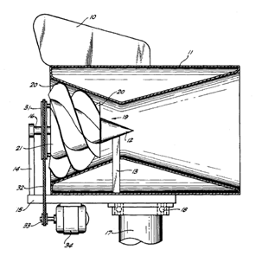
Carpenter’s Patent #421875

In 1980, Robert D. Carpenter received a patent combined a Laval Nozzle with a cumbersome and aerodynamically inefficient helical turbine. US patent #4218175 has since expired. The Laval Nozzle included both a converging and diverging section, as well as an external and internal wall. Consequently the unit was cumbersome, heavy and difficult to field. Compounding this, the unit was inefficient primarily due to rather arcane turbine technology that was incorporated. The vTurbine™ corrects these deficiencies by combining state-of-the art turbine blade technology with a truncated conical single-walled sail. This combination is lighter, smaller and superior than the technology of #4218175. Enhancing our current position are the availability of composite materials and better understanding of turbine blade technology. This patent would be cited as prior art, but the truncation of the Laval Nozzle into a conical sail is both a significant and non-obvious improvement to the design.

Patent Area Three – Stability and Control
Preliminary versions of the vTurbine™ showed that sail stability and control are important attributes of a fully featured unit. Naïve implementations of our concept will have oscillation problems that we have already encountered and solved in an ambitious prototyping campaign. This gives us an advantage in time-to-market.

IP - TRADEMARKS

Trademarks whose registration is pending include

vTurbine™

vSail™

vTower™

IP– COPYRIGHTS AND TRADE SECRETS

Software implemented for the purpose of monitoring the system is copyrighted by default under the Digital Millennium Copyright Act (DMCA). In addition disclosure of the source code of the software will be tightly controlled. Because of the compilation and loading of the software into the microcontrollers, it will be extremely difficult to reverse engineer the compiled machine code into anything recognizable or useful.

